***CAPSTONE PROJECT-ABDULLAH GHOUS-BATCH---1***

***Project Introduction***

***About the Application***

***The project focuses on developing and deploying a Book-My-Show clone application, which simulates an online movie and event ticket booking platform. The application allows users to:***

* ***Browse available movies and events.***
* ***Check show timings and seat availability.***
* ***Book tickets through a user-friendly interface.***
* ***Manage bookings efficiently.***

***This use case was selected because it closely mirrors a real-world business scenario, where multiple services interact, and scalability, reliability, and continuous delivery are essential. It also provides an ideal foundation for applying DevOps principles in a hands-on manner.***

***Why This Application***

***The Book-My-Show clone was chosen as the base application for several reasons:***

1. ***Real-world relevance – Online ticket booking is a well-understood domain, making it easy to relate DevOps practices to actual business outcomes.***
2. ***Complexity of components – The app requires backend services, frontend UI, databases, and external integrations, making it a great candidate to practice containerization, deployment, and monitoring.***
3. ***Scalability needs – As user load grows, the application must scale seamlessly, which highlights the importance of Kubernetes, monitoring, and load balancing.***
4. ***End-to-end DevOps demonstration – The project covers the complete DevOps lifecycle:***
   * ***Plan (using Jira for project/task tracking)***
   * ***Code & Build (using GitHub, Jenkins, Maven)***
   * ***Test (using SonarQube for quality, Trivy/OWASP for security scanning)***
   * ***Release & Deploy (using Docker, Kubernetes, AWS EKS)***
   * ***Monitor & Improve (using Prometheus and Grafana)***

***Tool Stack Used***

***The project leverages a comprehensive DevOps toolchain:***

***🔹 Project Management & Collaboration***

* ***Jira – For defining epics, stories, and tasks, and for tracking progress from backlog to completion.***
* ***GitHub – For source code management, pull requests, and collaboration.***

***🔹 CI/CD Automation***

* ***Jenkins – Automates the CI/CD pipeline, including building, testing, containerizing, and deploying the app.***
* ***Jenkinsfile – Defines pipeline stages (build, test, quality scan, Docker image build, push to registry, deployment).***

***🔹 Code Quality & Security***

* ***SonarQube – Performs static code analysis and enforces Quality Gates for code maintainability, reliability, and security.***
* ***dependencies for known vulnerabilities.***

***🔹 Containerization & Image Management***

* ***Docker – Packages the application into containers for portability and consistency across environments.***
* ***DockerHub – Stores and shares Docker images, enabling smooth deployment to Kubernetes clusters.***

***🔹 Infrastructure & Orchestration***

* ***Terraform – Automates provisioning of AWS resources, ensuring infrastructure is reproducible and version-controlled.***
* ***Amazon EKS (Elastic Kubernetes Service) – Provides a managed Kubernetes environment for deploying and managing containerized workloads.***
* ***Kubernetes – Handles application deployment, scaling, and load balancing via Pods, Deployments, and Services.***

***🔹 Monitoring & Alerting***

* ***Prometheus – Collects real-time metrics from applications and infrastructure.***
* ***Grafana – Visualizes metrics on interactive dashboards for monitoring performance and availability.***
* ***Email Notifications – Alerts stakeholders on pipeline status (success/failure).***

***Expected Outcome***

***By the end of this project, the application is fully automated through a CI/CD pipeline, deployed on a scalable Kubernetes cluster, continuously monitored, and maintained with proper quality checks and security scans. The project demonstrates how DevOps practices ensure faster delivery, better collaboration, higher code quality, and improved reliability of modern applications.***

TASK-1-JIRA

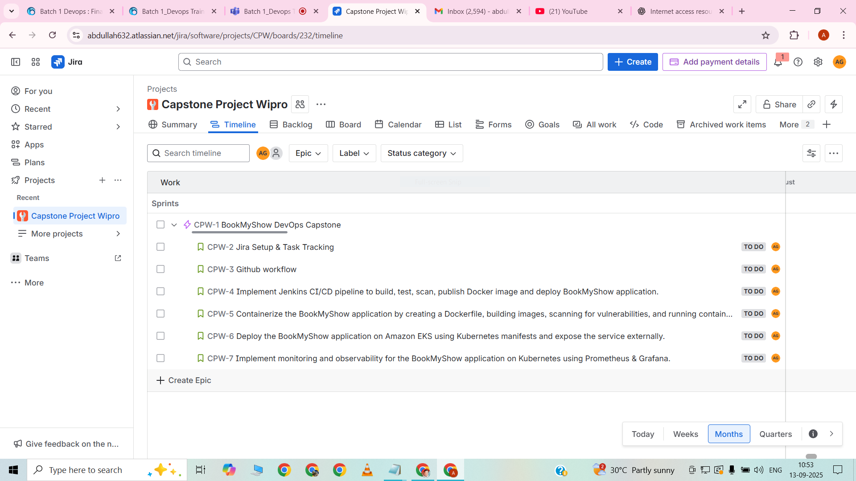

* *“Timeline view of the BookMyShow DevOps Capstone project in Jira.”*
* *“One Epic ‘BookMyShow DevOps Capstone’ created to organize the project.”*
* *“Stories created for each DevOps stage: Jira, GitHub, Jenkins, Docker, Kubernetes, and Monitoring.”*
* *“All stories are assigned to the project owner (Abdullah Ghous) and scheduled across the sprint timeline.”*
* *“This view visualizes task progress and ensures end-to-end tracking of the capstone project.*

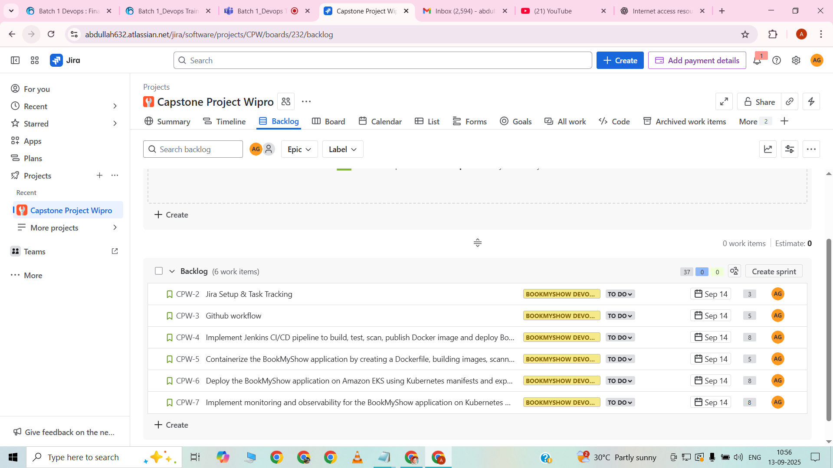

* Backlog view of the BookMyShow DevOps Capstone project in Jira
* All stories (Jira, GitHub, Jenkins, Docker, Kubernetes, Monitoring) listed in the backlog
* Shows each story’s summary, priority, and sprint assignment
* Allows drag-and-drop of stories into sprints for planning and scheduling
* Provides a central view to manage and track tasks before starting the sprint

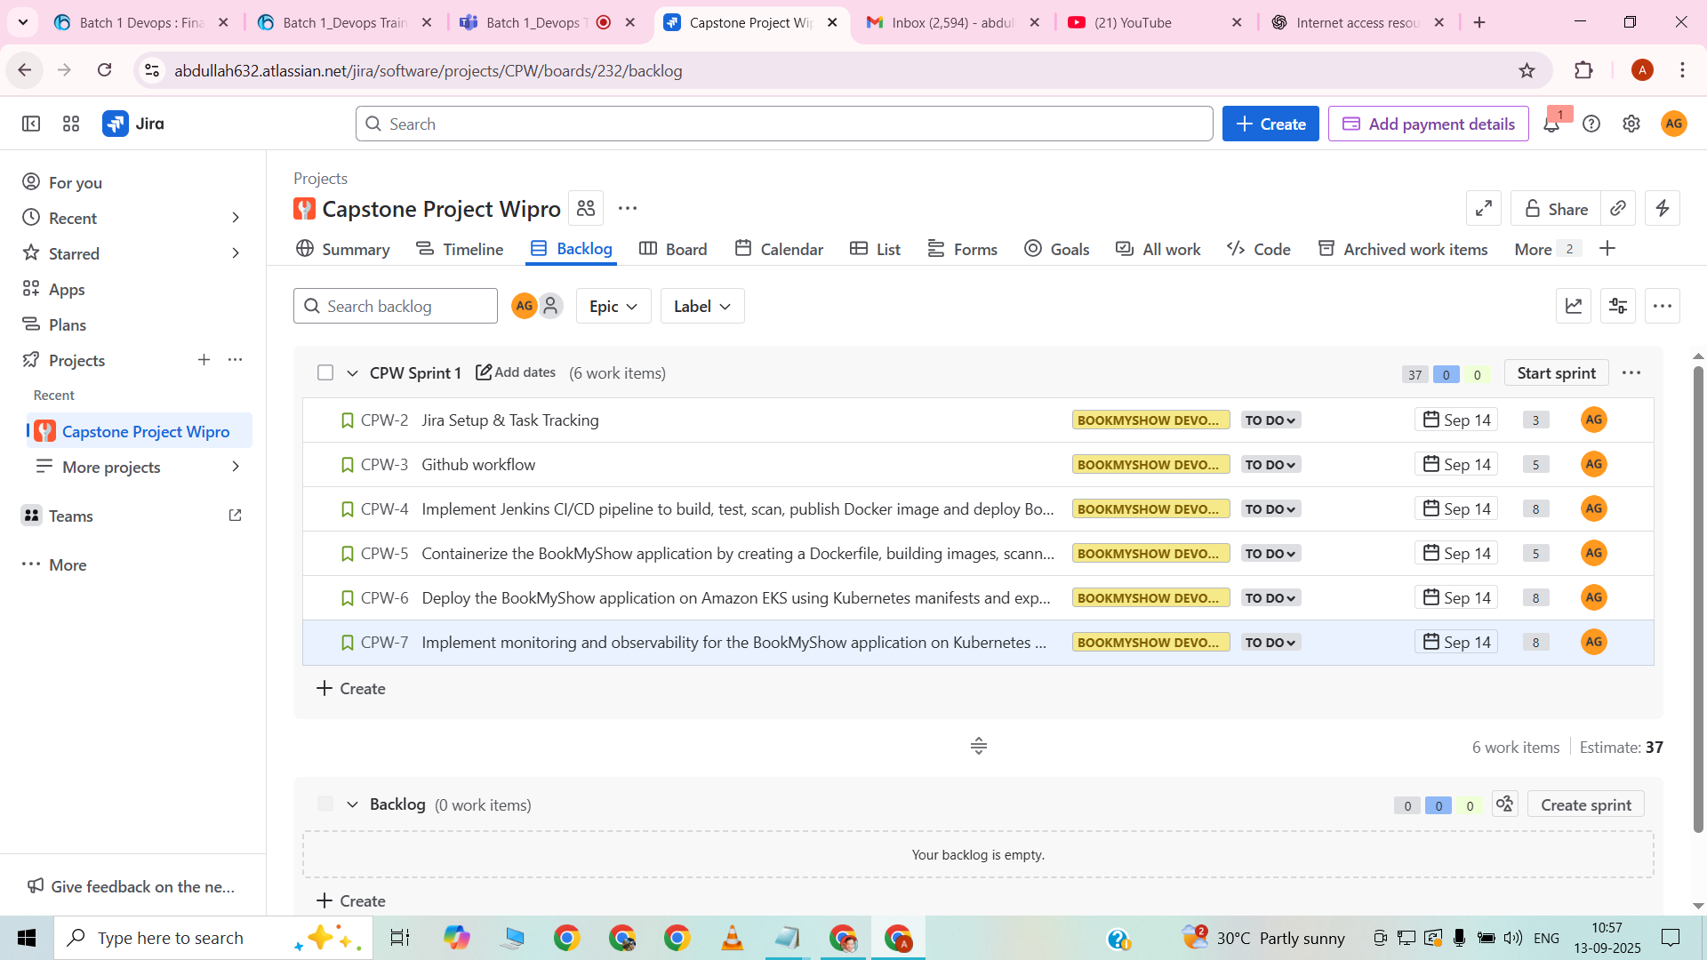

* Sprint planning view after dragging all stories into the active sprint
* Stories for Jira, GitHub, Jenkins, Docker, Kubernetes, and Monitoring included in the sprint
* Displays start and due dates, assignee (Abdullah Ghous), and story points
* Helps visualize which tasks are scheduled for the current sprint
* Ensures proper tracking and progress during sprint execution

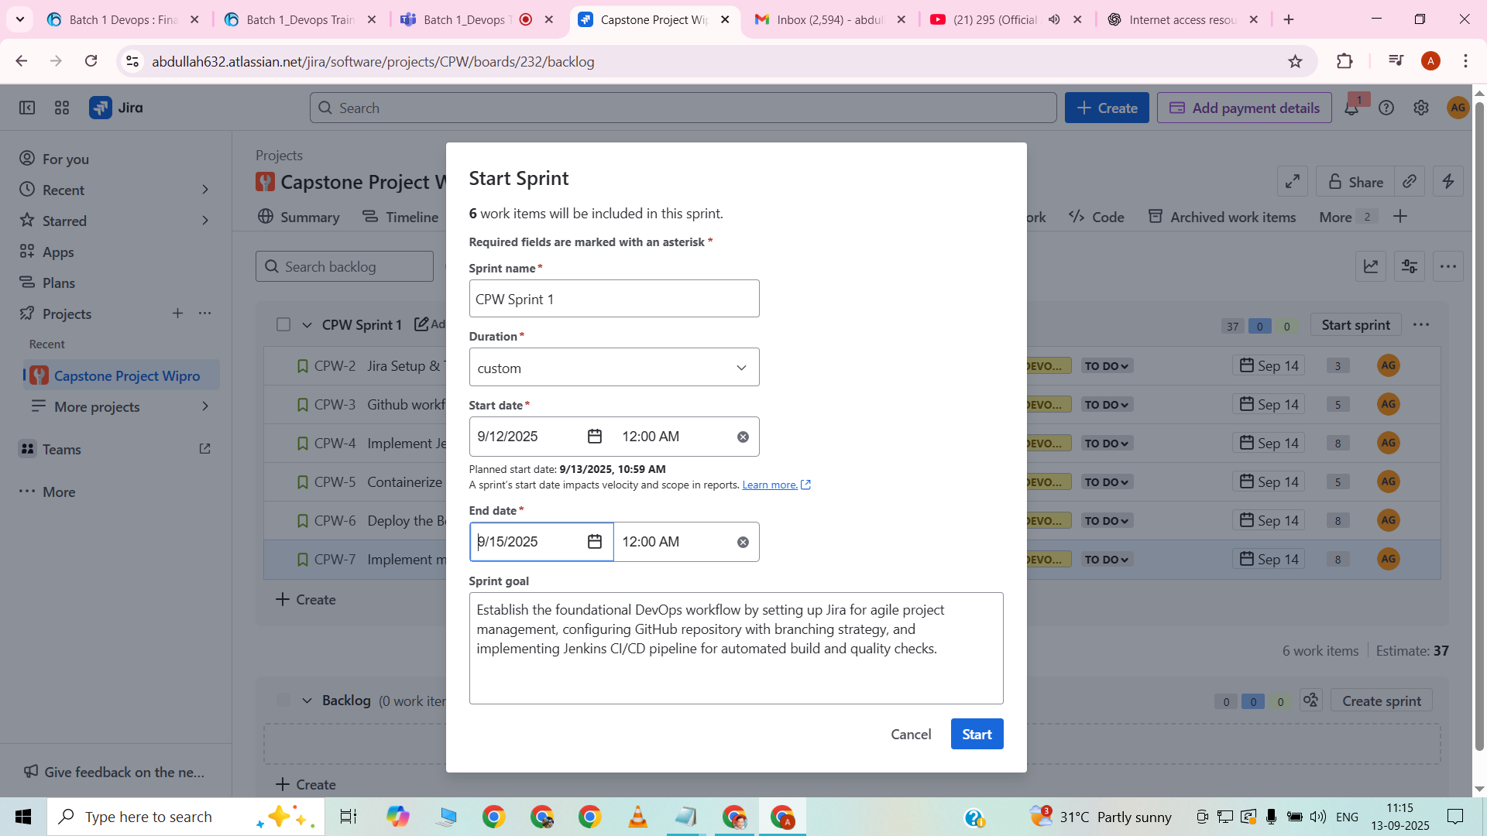

Sprint creation popup in Jira showing sprint name, start and end dates, and sprint goal

Sprint Name: “CPW-sprint-1”

Duration: 09/12/2025 to 09/15/2025

Sprint Goal: *“Complete setup and planning for BookMyShow DevOps Capstone; assign all stories for GitHub, Jenkins, Docker, Kubernetes, and Monitoring tasks.”*

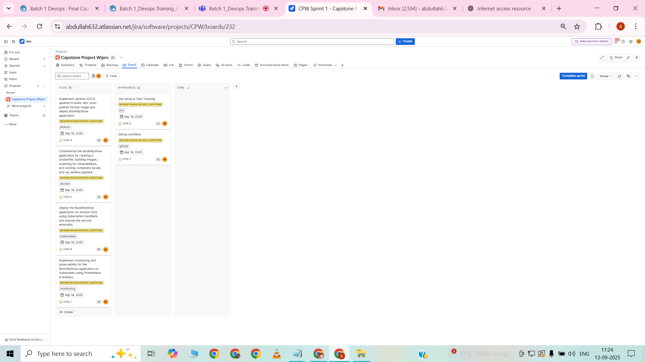

Jira board showing sprint tasks in progress  
Stories for Jira and GitHub assigned to me  
Tasks moved from To Do to In Progress  
Visual representation of work started  
Helps track active sprint progress

TASK-2-GITHUB/GIT

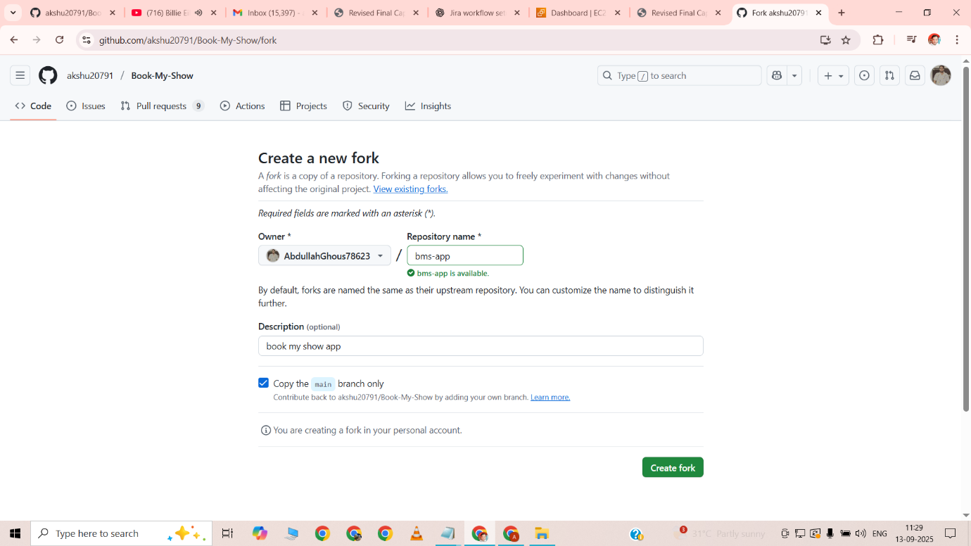

Forked the GitHub repository to my own account  
Created a copy to work independently from the original repo  
This allowed me to push changes without affecting the main repository  
Ensured proper GitHub workflow for feature development

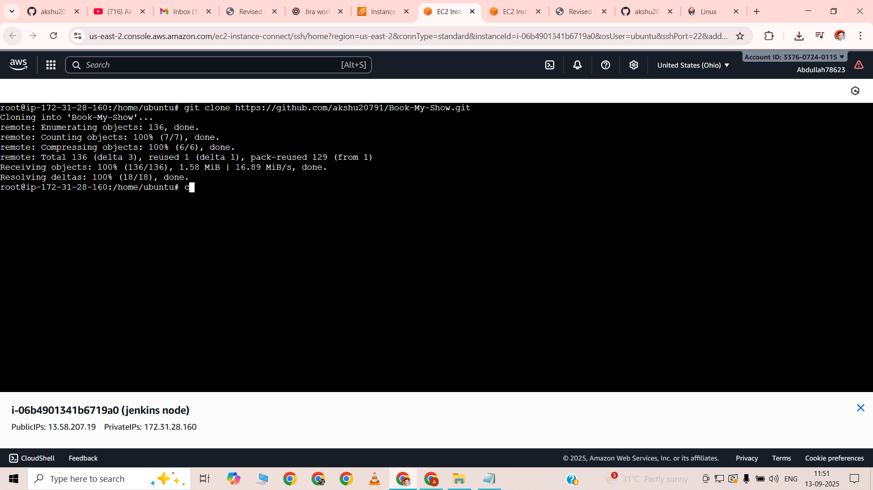

Cloned the repository into the EC2 instance  
Set up the local environment for development and deployment  
Enabled direct integration with Jenkins and Docker on the server  
Prepared the codebase for building and running containers

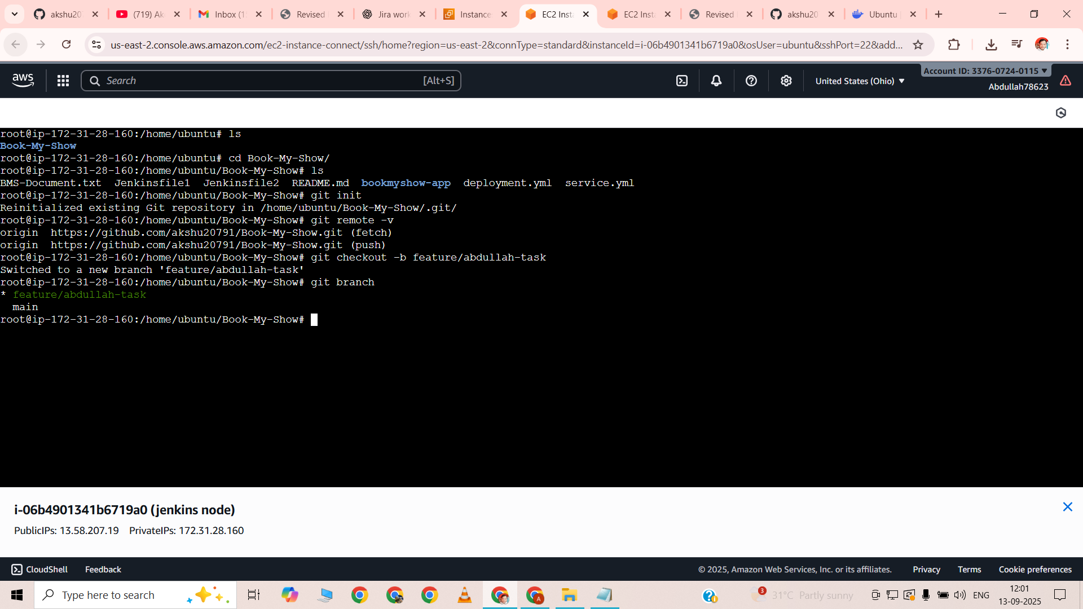

Created a new branch named **feature/abdullah-task**  
Switched from the main branch to the new feature branch  
Isolated changes for better version control and tracking  
Prepared to work on tasks without affecting the main branch

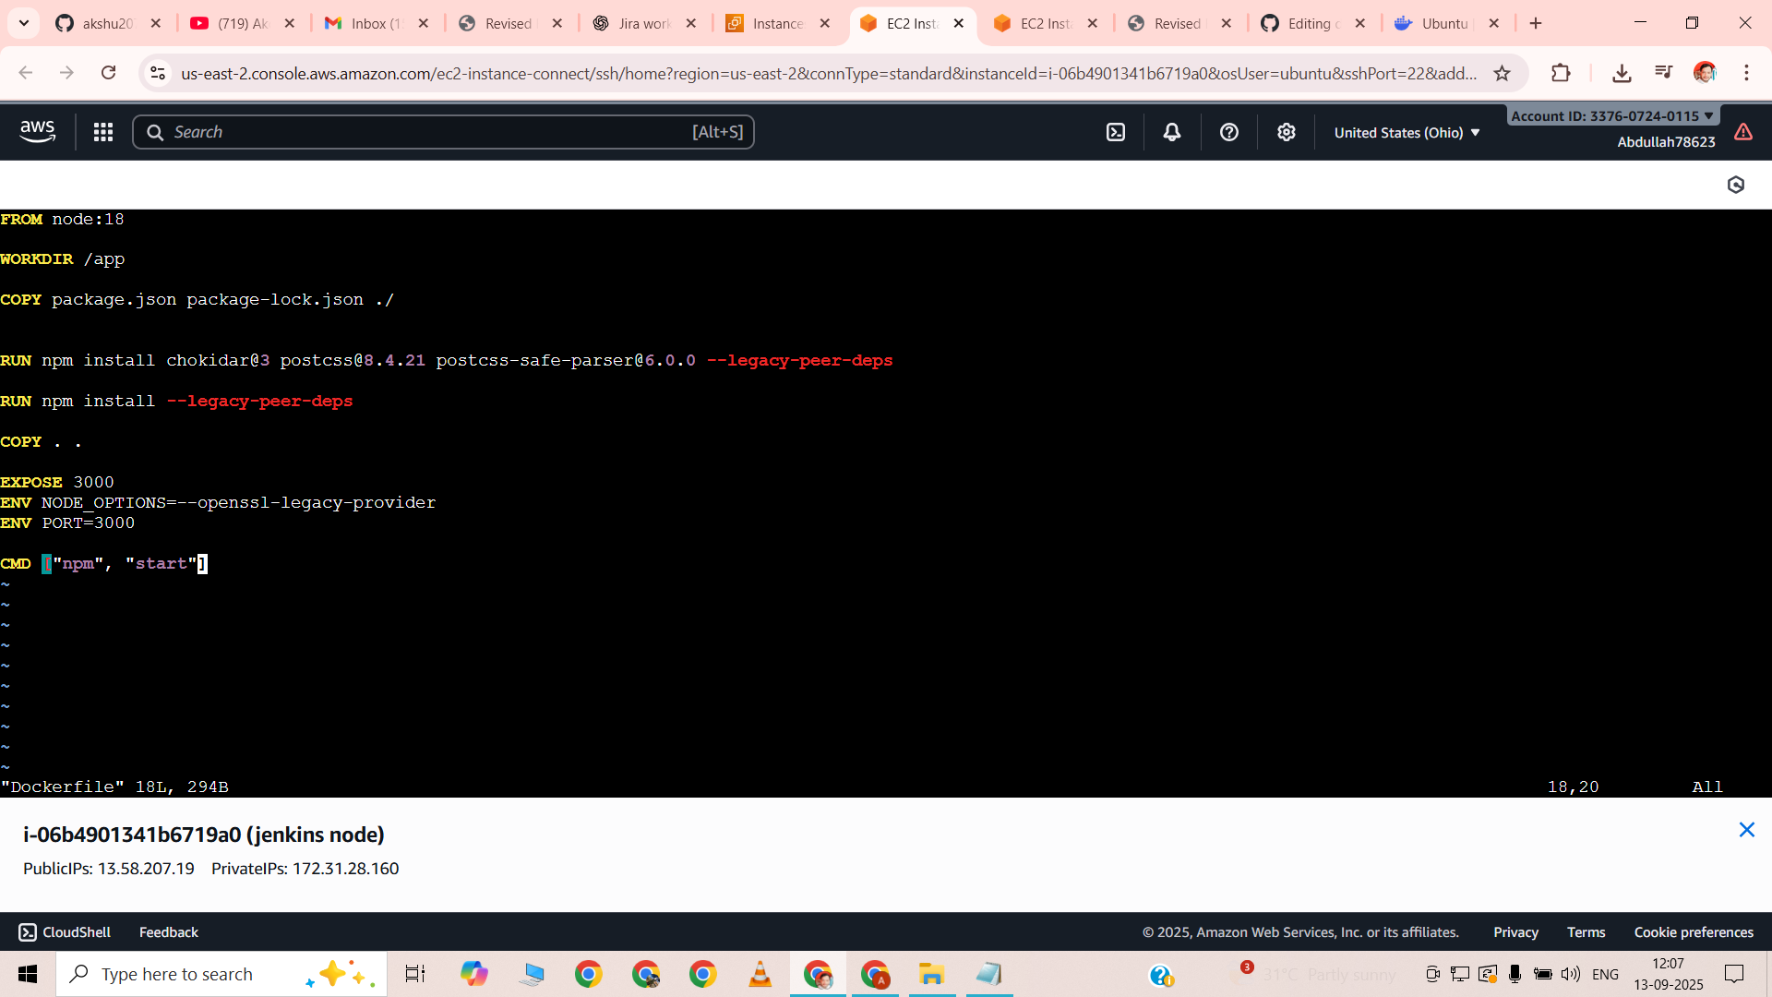

Created a **Dockerfile** for containerizing the React application  
Used **node:18** as the base image  
Set the working directory to **/app** inside the container  
Copied **package.json** and **package-lock.json** for dependency installation  
Installed required dependencies including chokidar, postcss, and postcss-safe-parser  
Copied all project files into the container  
Exposed port **3000** for application access  
Set environment variables for compatibility  
Defined the start command to run the app with **npm start**

**DOCKERFILE**

FROM node:18

WORKDIR /app

COPY package.json package-lock.json ./

RUN npm install chokidar@3 postcss@8.4.21 postcss-safe-parser@6.0.0 --legacy-peer-deps

RUN npm install --legacy-peer-deps

COPY . .

EXPOSE 3000

ENV NODE_OPTIONS=--openssl-legacy-provider

ENV PORT=3000

CMD ["npm", "start"]

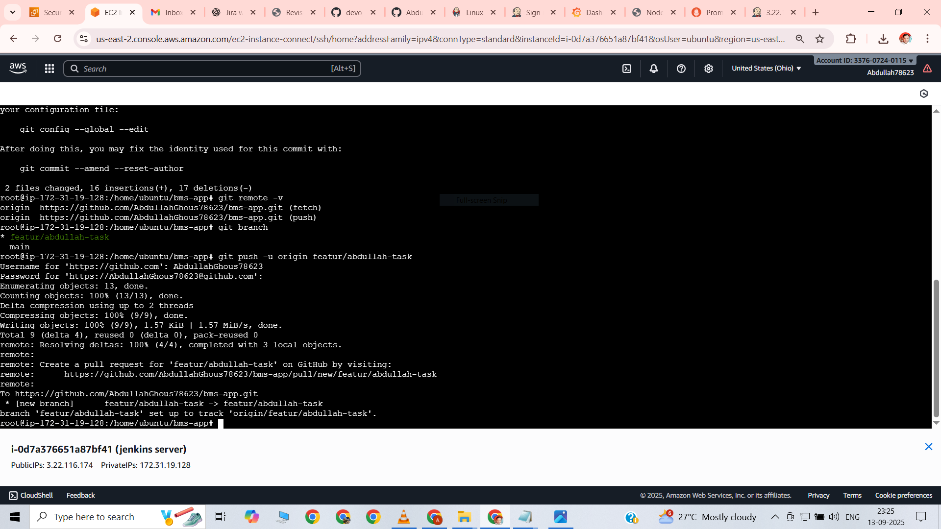

Forked the repository from GitHub  
Cloned the repository into EC2 instance  
Created a new branch feature/abdullah-task  
Wrote the Dockerfile for the project  
Created a pull request after completing changes

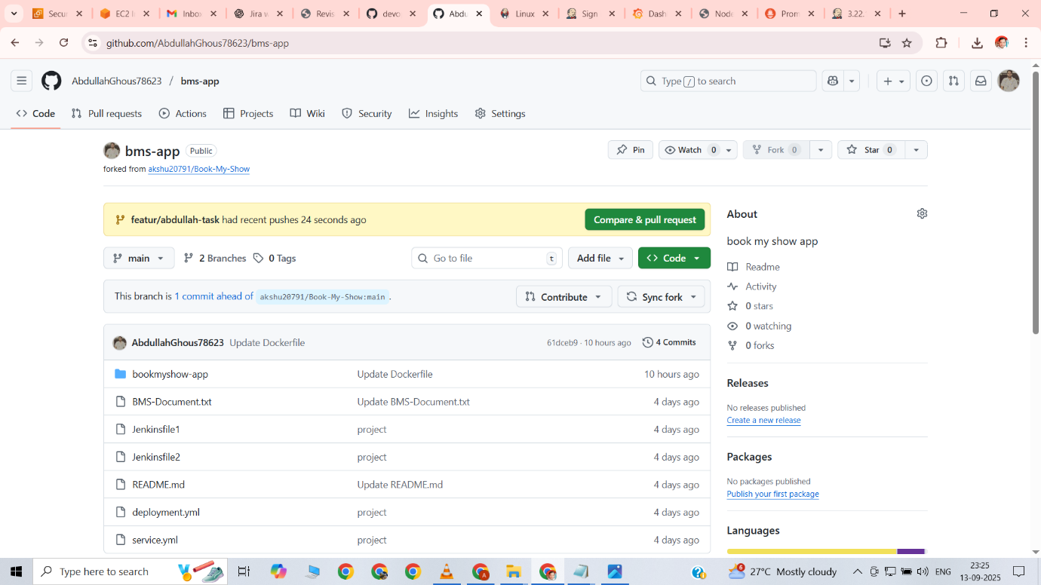

Opened the compare and pull request page on GitHub  
Compared the feature branch with the main branch  
Reviewed the changes made in the feature branch  
Initiated a pull request for merging changes into main branch

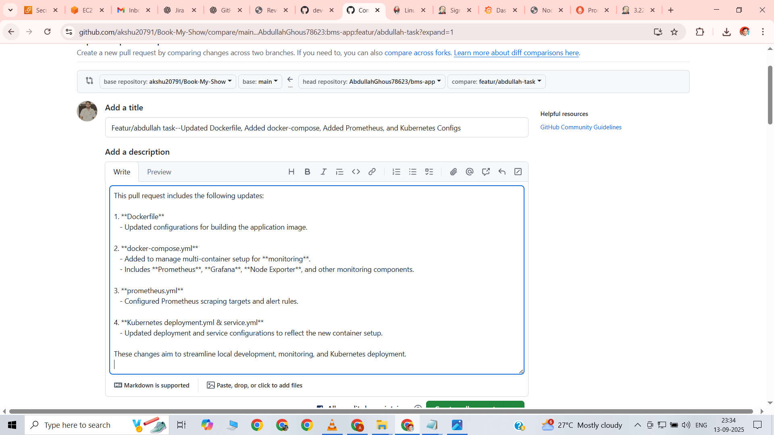

Entered a suitable title for the pull request  
Added a brief description of the changes made  
Ensured clarity so reviewers understand the purpose of the pull request

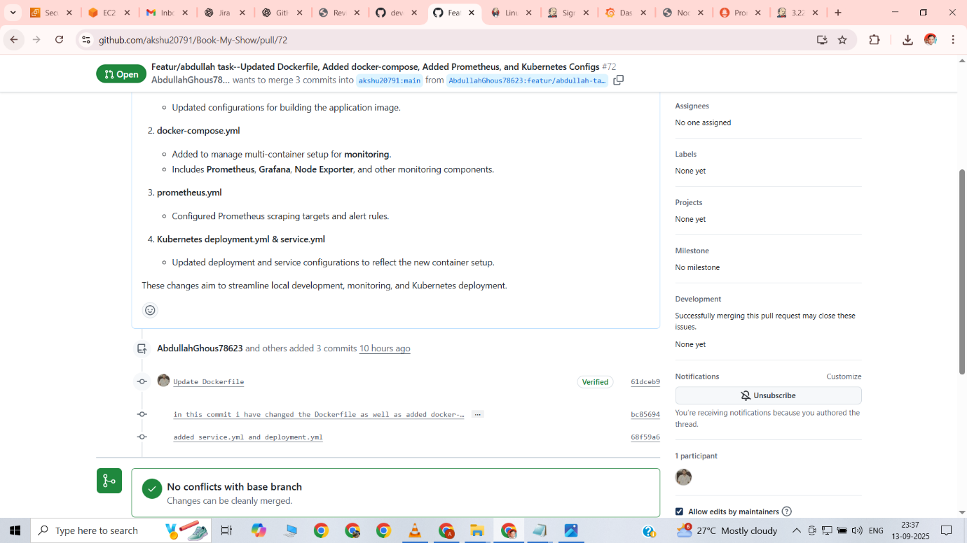

Pull request created successfully  
No conflicts detected with the base branch  
Changes are ready to be reviewed

TASK-3-JENKINS

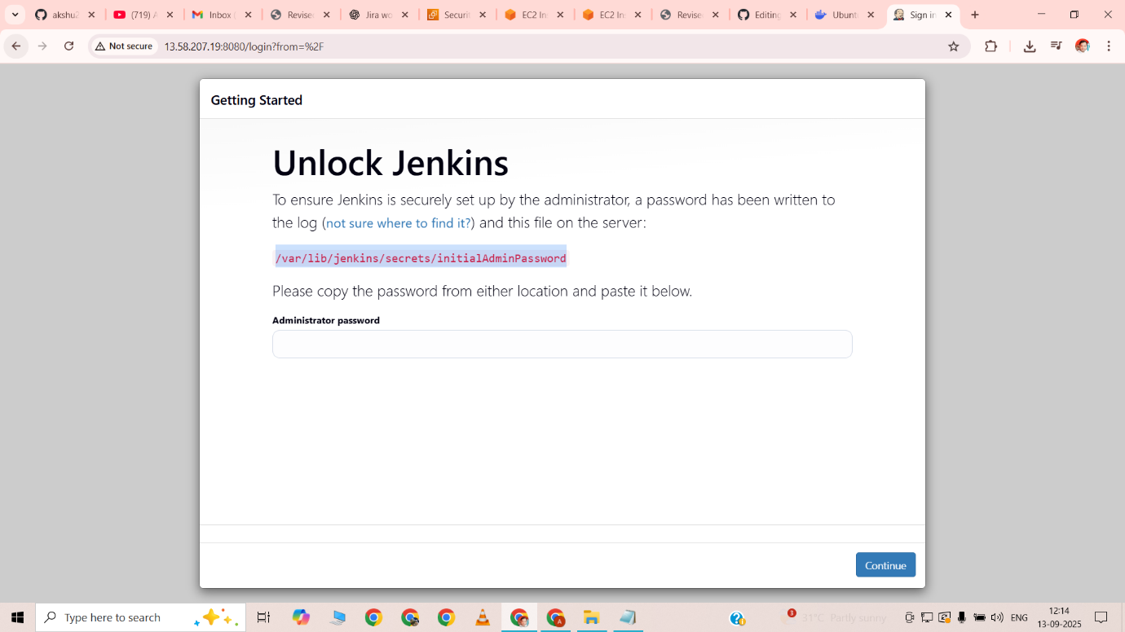

Accessed Jenkins on port 8080  
Successfully logged in to Jenkins dashboard  
Ready to configure jobs for CI/CD pipeline

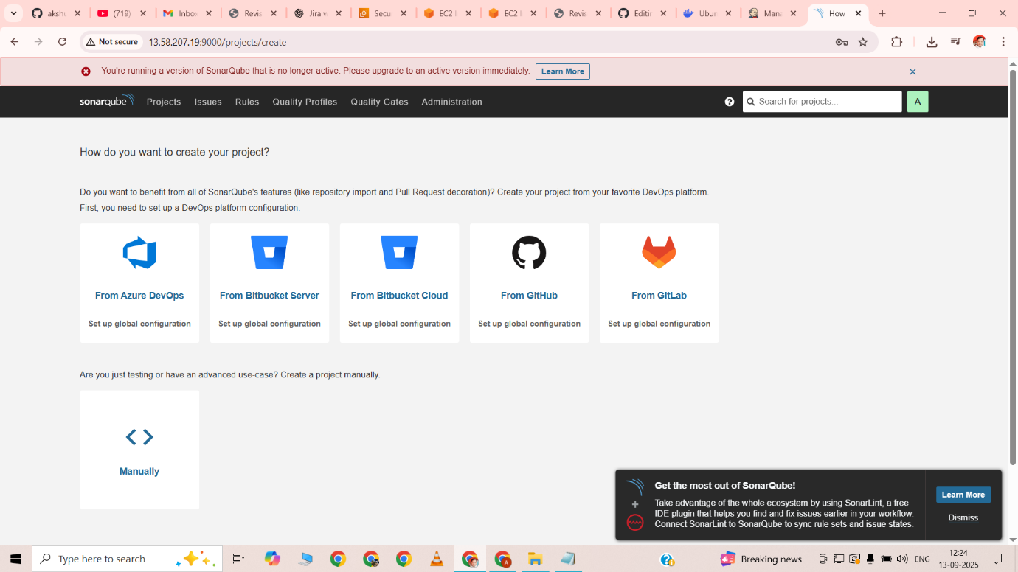

Accessed SonarQube on port 9000  
Successfully logged in to SonarQube dashboard  
Ready to configure projects and perform code quality analysis

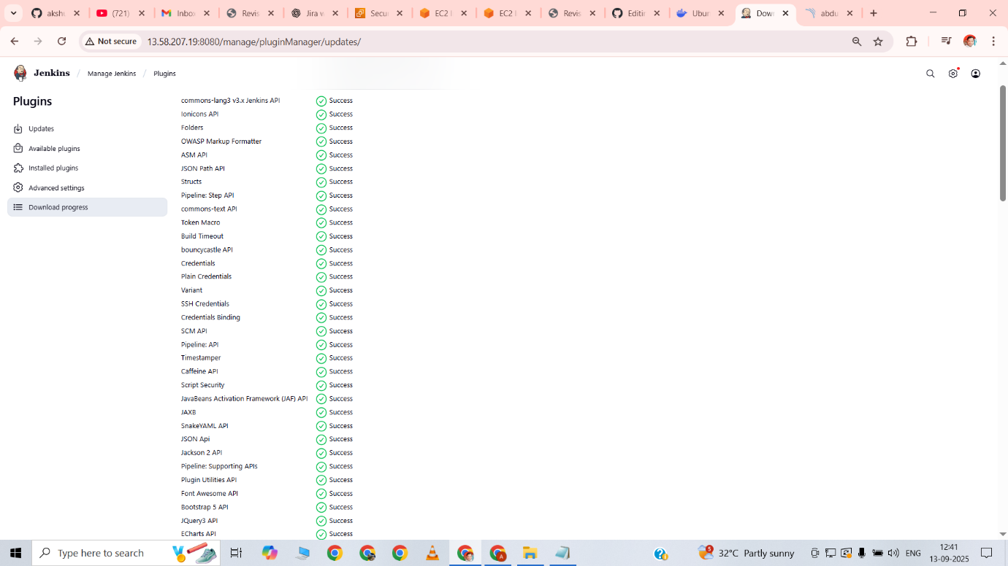

Installed all required Jenkins plugins for Docker integration  
Installed additional plugins for SonarQube integration  
Configured Jenkins to support CI/CD pipelines for the project

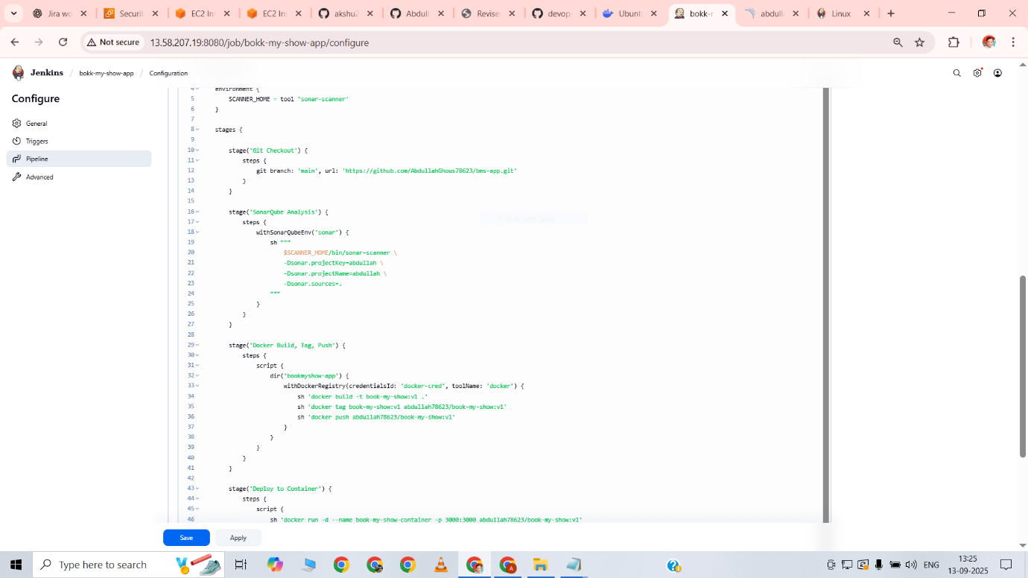

Created a Jenkins pipeline using a Jenkinsfile  
Configured Git checkout to pull code from the main branch of the repository  
Integrated SonarQube analysis to perform code quality checks  
Built Docker image for the application, tagged it, and pushed to DockerHub  
Deployed the Docker container on port 3000 for application access

JENKINSFILE

pipeline {

agent any

environment {

SCANNER_HOME = tool 'sonar-scanner'

}

stages {

stage('Git Checkout') {

steps {

git branch: 'main', url: 'https://github.com/AbdullahGhous78623/bms-app.git'

}

}

stage('SonarQube Analysis') {

steps {

withSonarQubeEnv('sonar') {

sh """

$SCANNER_HOME/bin/sonar-scanner \

-Dsonar.projectKey=abdullah \

-Dsonar.projectName=abdullah \

-Dsonar.sources=.

"""

}

}

}

stage('Docker Build, Tag, Push') {

steps {

script {

dir('bookmyshow-app') {

withDockerRegistry(credentialsId: 'docker-cred', toolName: 'docker') {

sh 'docker build -t book-my-show:v1 .'

sh 'docker tag book-my-show:v1 abdullah78623/book-my-show:v1'

sh 'docker push abdullah78623/book-my-show:v1'

}

}

}

}

}

stage('Deploy to Container') {

steps {

script {

sh 'docker run -d --name book-my-show-container -p 3000:3000 abdullah78623/book-my-show:v1'

}

}

}

}

}

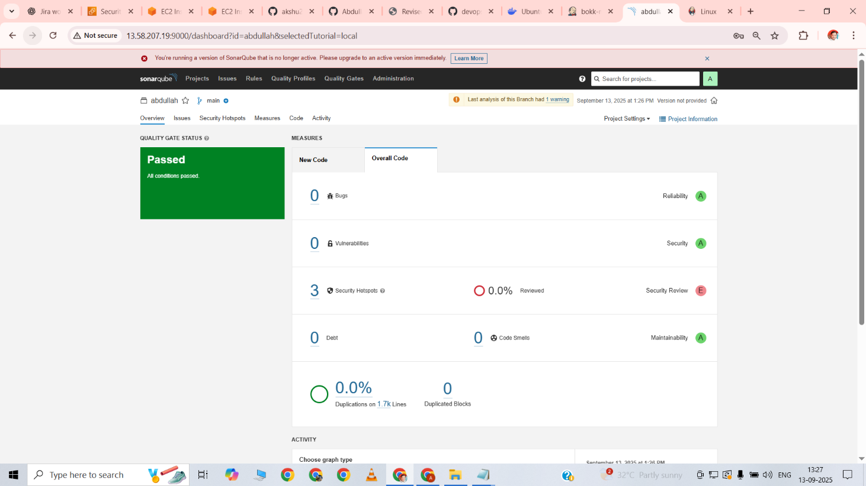

Successfully executed SonarQube analysis  
Quality gates passed with no critical issues  
Code quality and coverage reports generated and verified

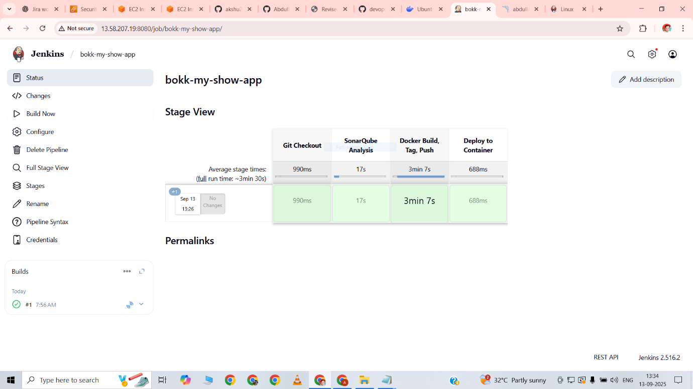

Accessed Jenkins stage view dashboard  
All pipeline stages executed successfully  
Git checkout, SonarQube analysis, Docker build, push, and deployment completed  
CI/CD pipeline verified as successful

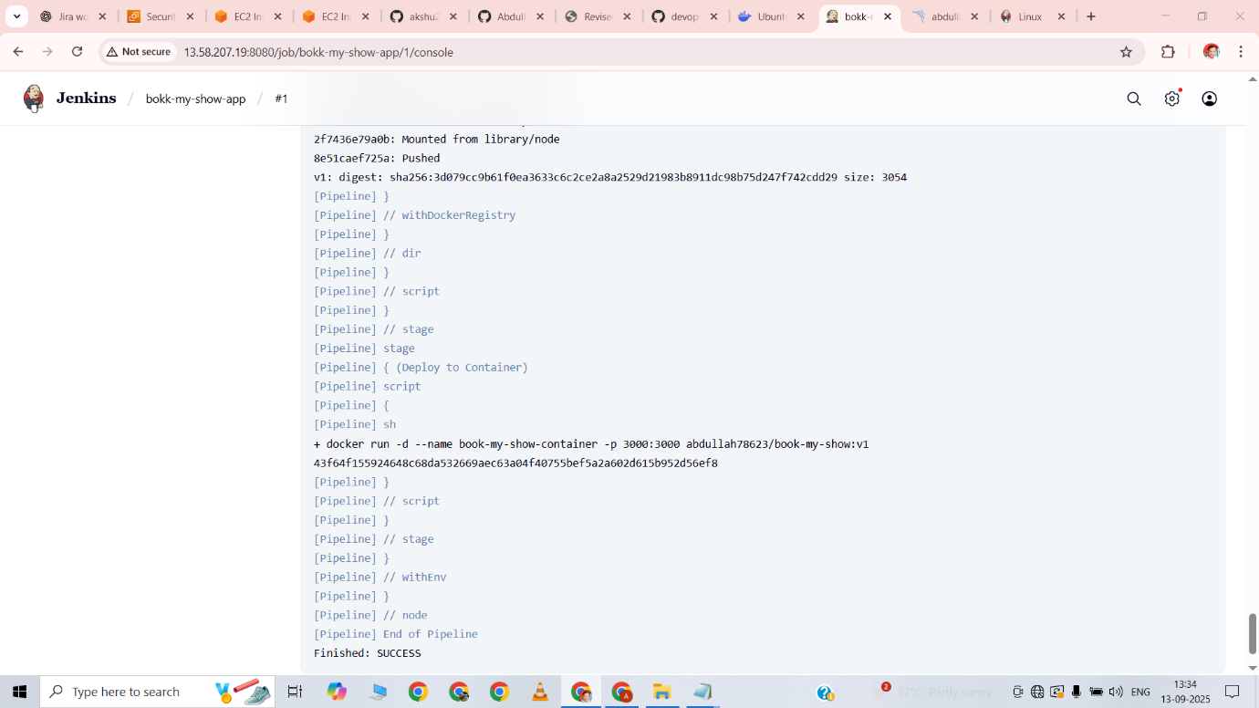

Checked Jenkins console output  
Pipeline executed successfully  
Received success messages for all stages  
CI/CD process confirmed as completed without errors



Accessed the Book-My-Show application on port 3000  
Verified that the application is running successfully in the Docker container  
Confirmed functionality and accessibility of the deployed app

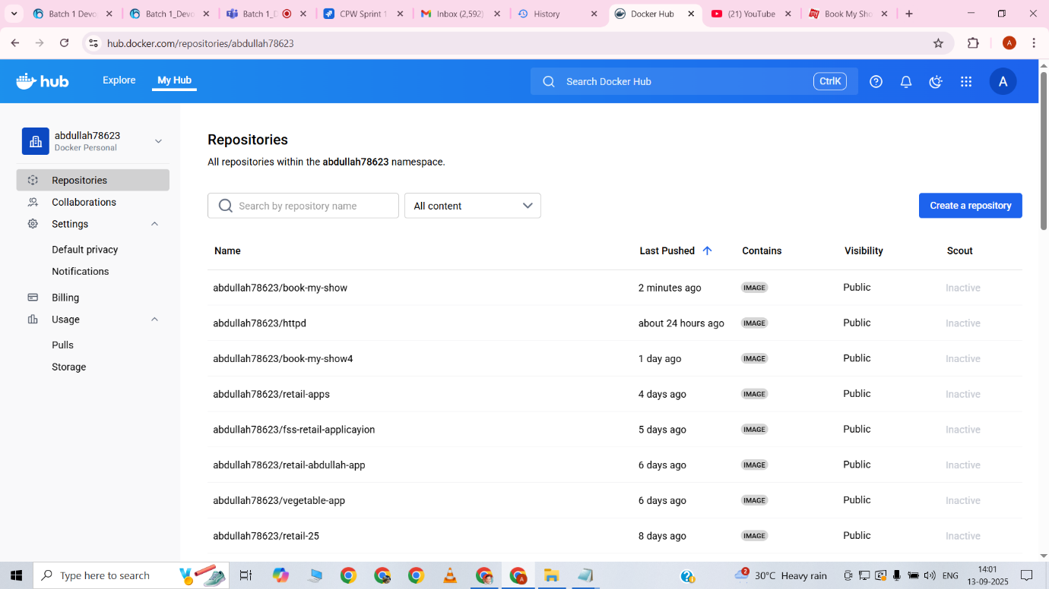

Verified Docker image pushed successfully to DockerHub  
Image tagged correctly as abdullah78623/book-my-show:v1  
Confirmed availability of the image for deployment on other environments

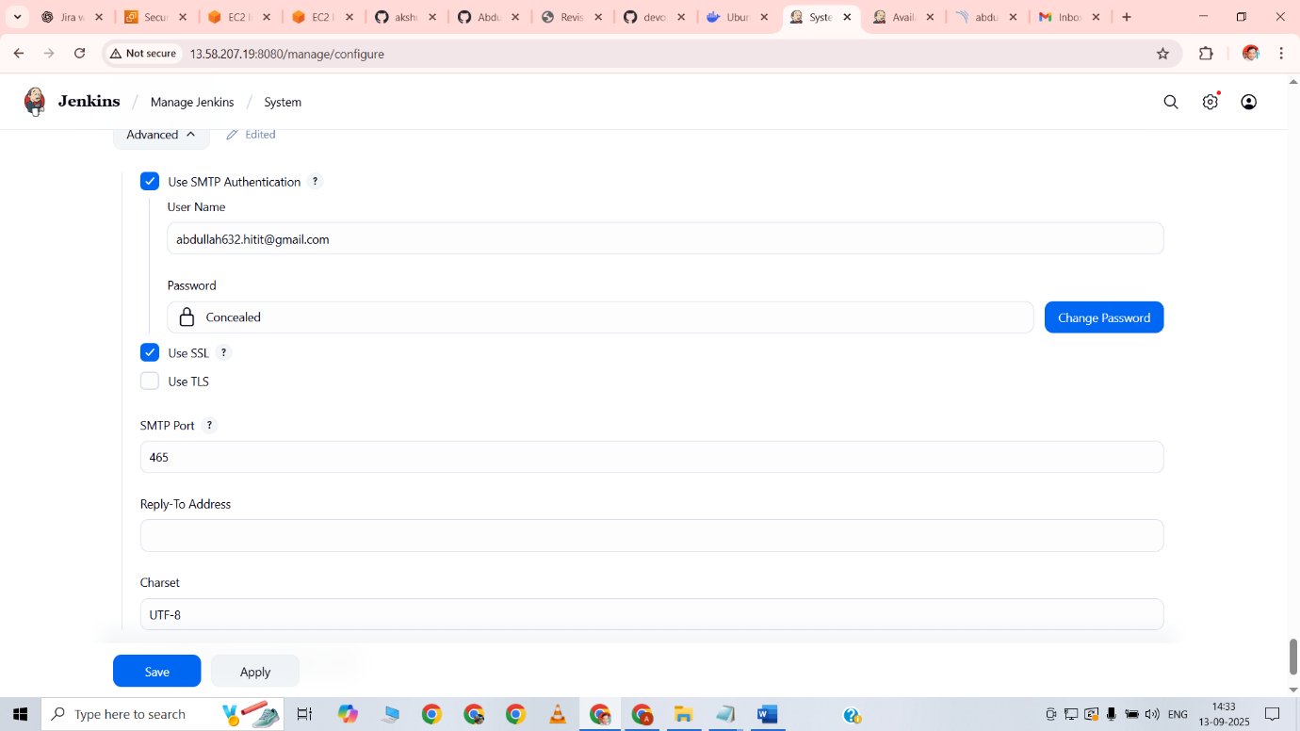

Step-1 for email

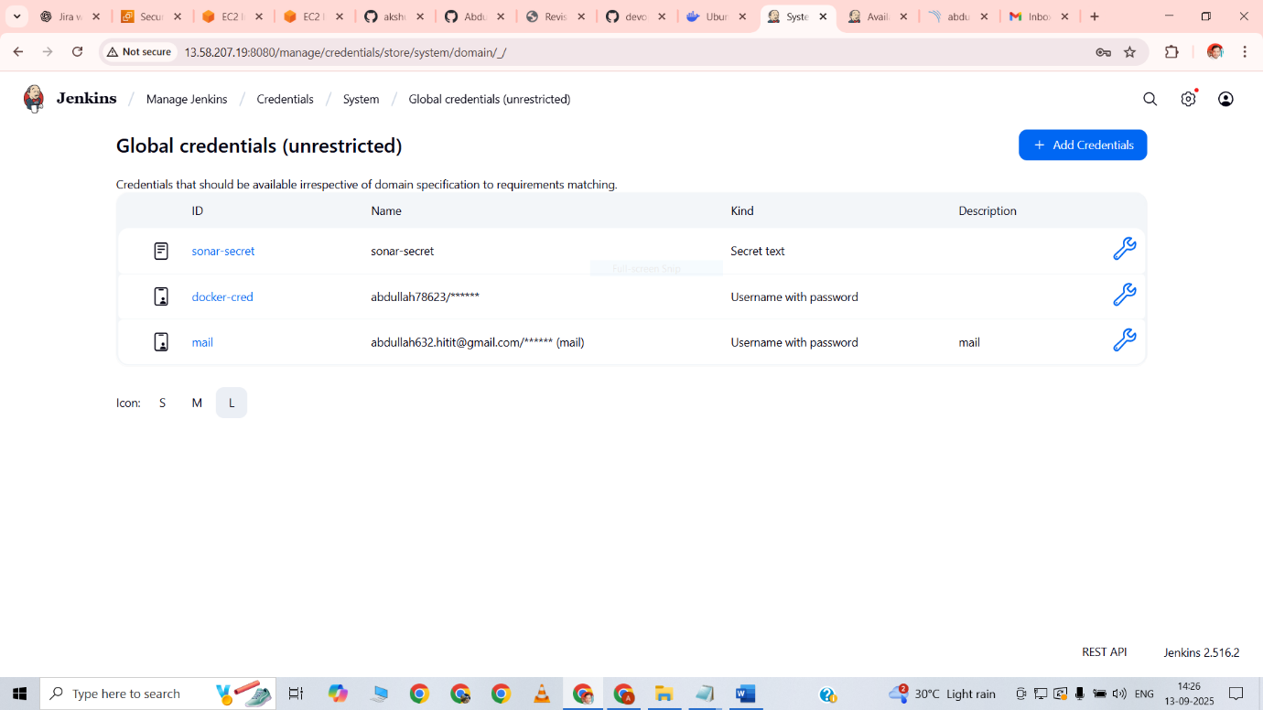

Added credentials for the email

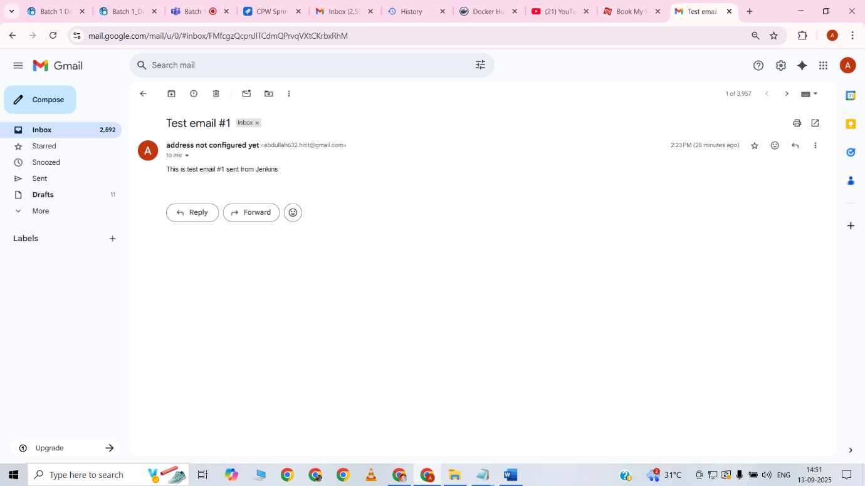

Test email received successfully

Wrote the new jenkinsfile for the email

pipeline {

agent any

environment {

SCANNER_HOME = tool 'sonar-scanner'

}

stages {

stage('Git Checkout') {

steps {

git branch: 'main', url: 'https://github.com/AbdullahGhous78623/bms-app.git'

}

}

stage('SonarQube Analysis') {

steps {

withSonarQubeEnv('sonar') {

sh """

${SCANNER_HOME}/bin/sonar-scanner \\

-Dsonar.projectKey=abdullah \\

-Dsonar.projectName=abdullah \\

-Dsonar.sources=.

"""

}

}

}

stage('Docker Build, Tag, Push') {

steps {

script {

dir('bookmyshow-app') {

withDockerRegistry(credentialsId: 'docker-cred', toolName: 'docker') {

sh 'docker build -t book-my-show1:v1 .'

sh 'docker tag book-my-show1:v1 abdullah78623/book-my-show1:v1'

sh 'docker push abdullah78623/book-my-show1:v1'

}

}

}

}

}

stage('Deploy to Container') {

steps {

script {

sh 'docker run -d --name book-my-show-container -p 3000:3000 abdullah78623/book-my-show1:v1"'

}

}

}

}

post {

success {

emailext (

subject: "SUCCESS: CI/CD Pipeline Passed",

body: """

Hi Abdullah,

✅ The Jenkins pipeline executed successfully.

- Code checkout ✅

- SonarQube Quality Gate ✅

- Docker Build & Push ✅

- Deployment ✅

You can check SonarQube report here:

http://13.58.207.19:9000/dashboard?id=abdullah&selectedTutorial=local

username: admin, password: 1234

Regards,

Jenkins

""",

to: 'abdullah632.hitit@gmail.com'

)

}

failure {

emailext (

subject: "FAILED: CI/CD Pipeline",

body: """

Hi Abdullah,

❌ The Jenkins pipeline has failed.

Please review the Jenkins console logs and fix the issue.

SonarQube Dashboard:

http://13.58.207.19:9000/dashboard?id=abdullah&selectedTutorial=local

username: admin, password: 1234

Regards,

Jenkins

""",

to: 'abdullah632.hitit@gmail.com'

)

}

}

}

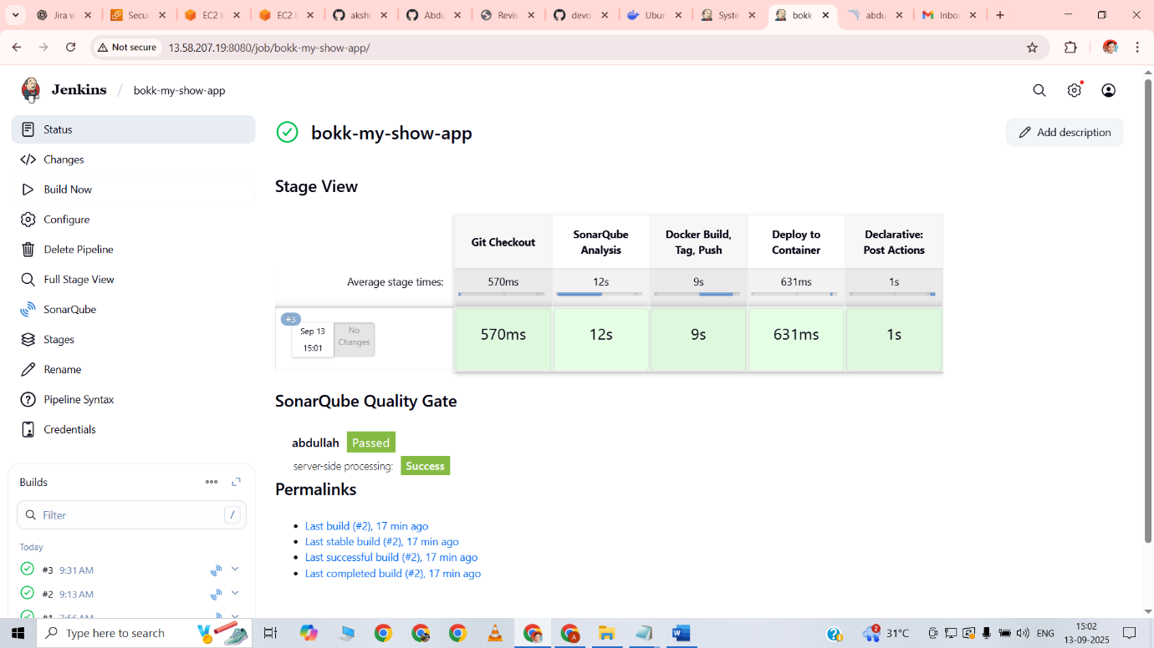

The pipeline got build successfully

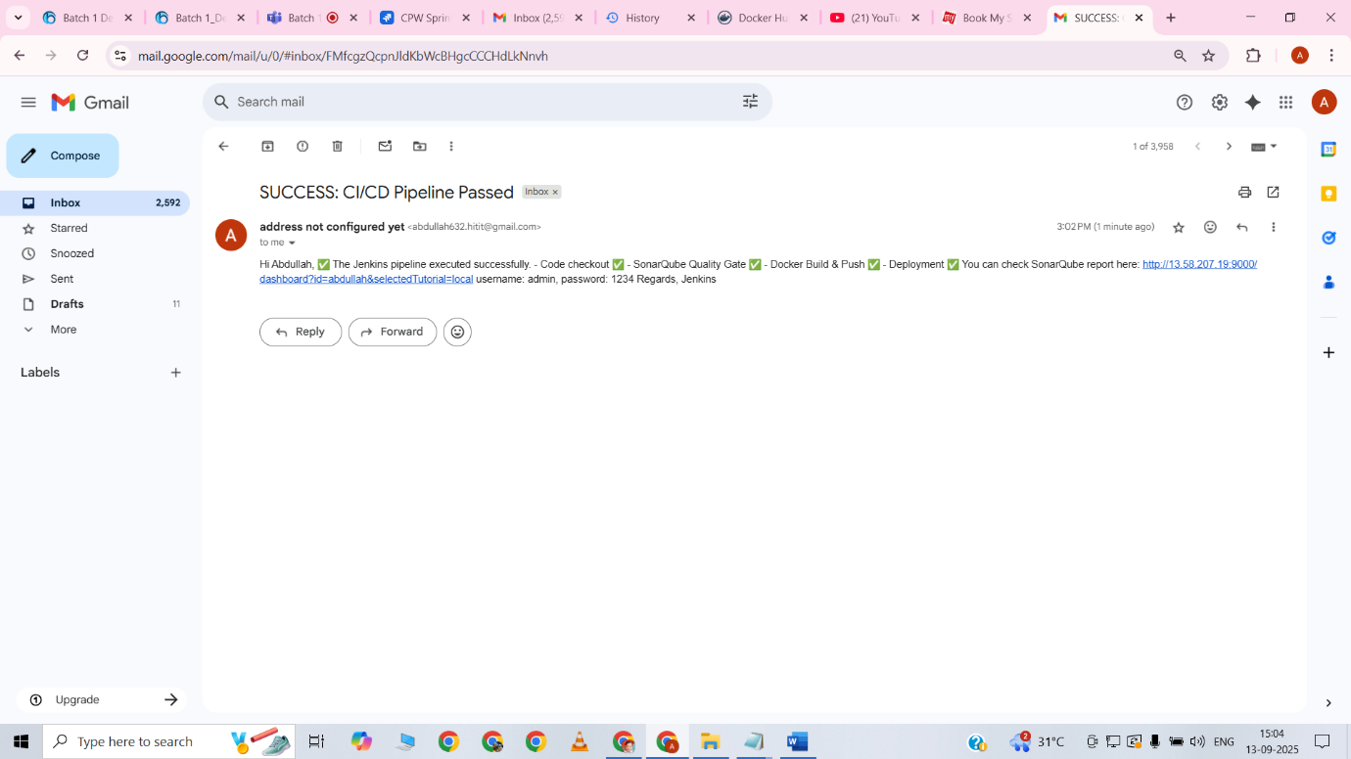

Configured email notifications in Jenkins pipeline  
Successfully sent build status email to abdullah632.hitit@gmail.com  
Confirmed receipt of email indicating pipeline execution result

TASK-4-DOCKER

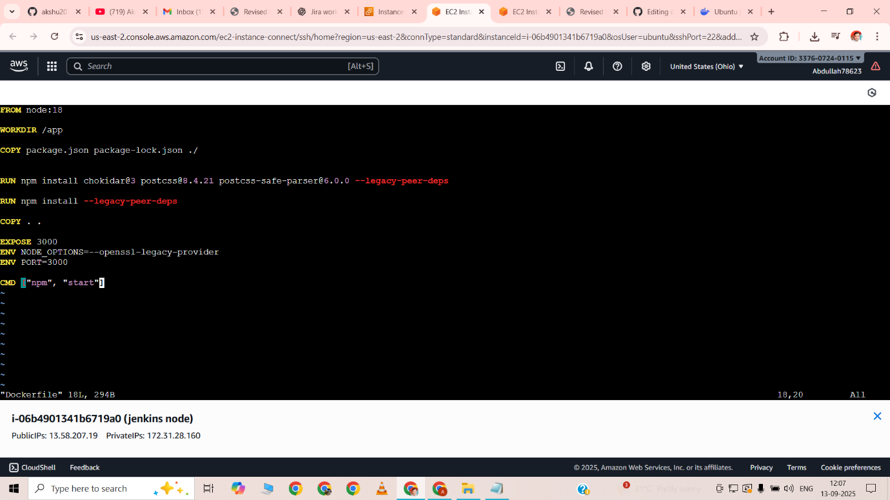

Created Dockerfile for the Book-My-Show application  
Used Node 18 as base image and set working directory to /app  
Copied project files and installed dependencies  
Exposed port 3000 and set environment variables  
Defined start command with npm start for container execution

Dockerfile-  
pipeline {

agent any

environment {

SCANNER_HOME = tool 'sonar-scanner'

}

stages {

stage('Git Checkout') {

steps {

git branch: 'main', url: 'https://github.com/AbdullahGhous78623/bms-app.git'

}

}

stage('SonarQube Analysis') {

steps {

withSonarQubeEnv('sonar') {

sh """

$SCANNER_HOME/bin/sonar-scanner \

-Dsonar.projectKey=abdullah \

-Dsonar.projectName=abdullah \

-Dsonar.sources=.

"""

}

}

}

stage('Docker Build, Tag, Push') {

steps {

script {

dir('bookmyshow-app') {

withDockerRegistry(credentialsId: 'docker-cred', toolName: 'docker') {

sh 'docker build -t book-my-show:v1 .'

sh 'docker tag book-my-show:v1 abdullah78623/book-my-show:v1'

sh 'docker push abdullah78623/book-my-show:v1'

}

}

}

}

}

stage('Deploy to Container') {

steps {

script {

sh 'docker run -d --name book-my-show-container -p 3000:3000 abdullah78623/book-my-show:v1'

}

}

}

}

}



Verified Jenkins pipeline execution in stage view  
All stages completed successfully  
Git checkout, Docker build, push, and deployment stages passed  
CI/CD process confirmed as successful

Success…..!



Verified the Docker image is available on DockerHub  
Image tagged as abdullah78623/book-my-show:v1  
Confirmed that the image can be pulled and used for deployment



Ran the Dockerfile locally on the EC2 instance without Jenkins  
Built and started the container successfully  
Accessed the application on port 3000 to verify it is working correctly

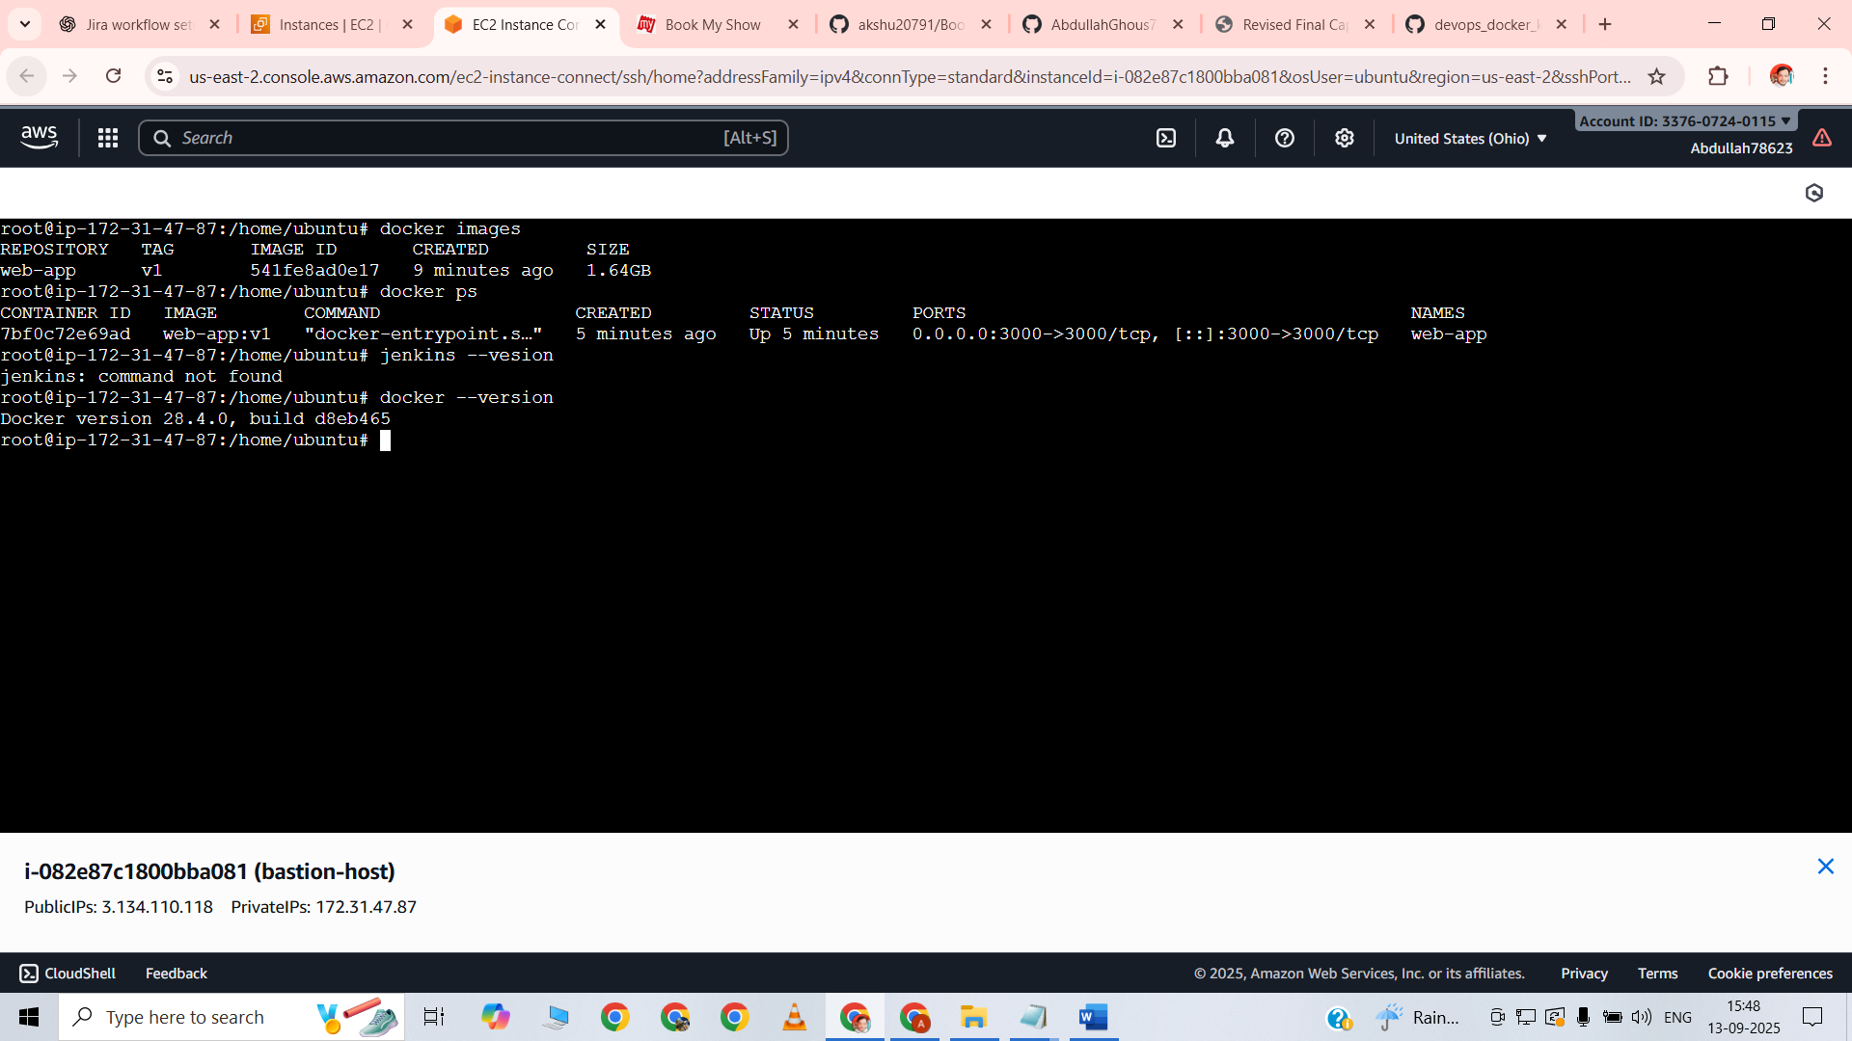

Checked Jenkins installation using jenkins --version command  
Confirmed that Jenkins was not installed initially on the EC2 instance  
Served as proof of fresh Jenkins setup before configuration

Initially verified the Docker environment on the EC2 instance by running the docker images command. This displayed all locally available Docker images, confirming that the newly built Book-My-Show image was present. Next, executed the docker ps command to list all running containers on the instance. This confirmed that the container for the Book-My-Show application was actively running and mapped correctly to port 3000. These steps served as proof that the Dockerfile was executed successfully, the image was built properly, and the application container was deployed and accessible locally on the EC2 instance without using Jenkins. This validated both the image creation and container runtime before integrating with the CI/CD pipeline.

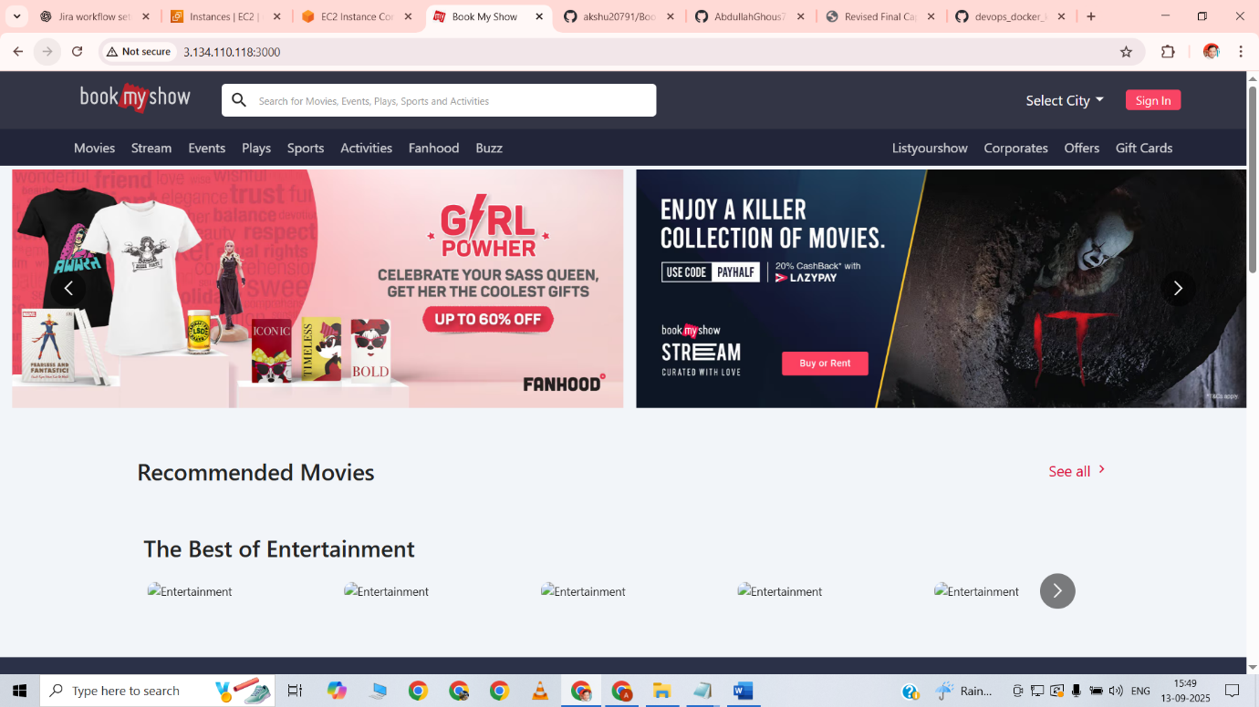

Accessed the Book-My-Show application running on the EC2 instance via port 3000. Verified that the application loaded successfully in the browser and was fully functional. All features and pages of the application responded as expected, confirming that the Docker container was running correctly and serving the application. This step validated the complete end-to-end deployment of the application locally on the EC2 instance.

TASK-5----KUBERNETES

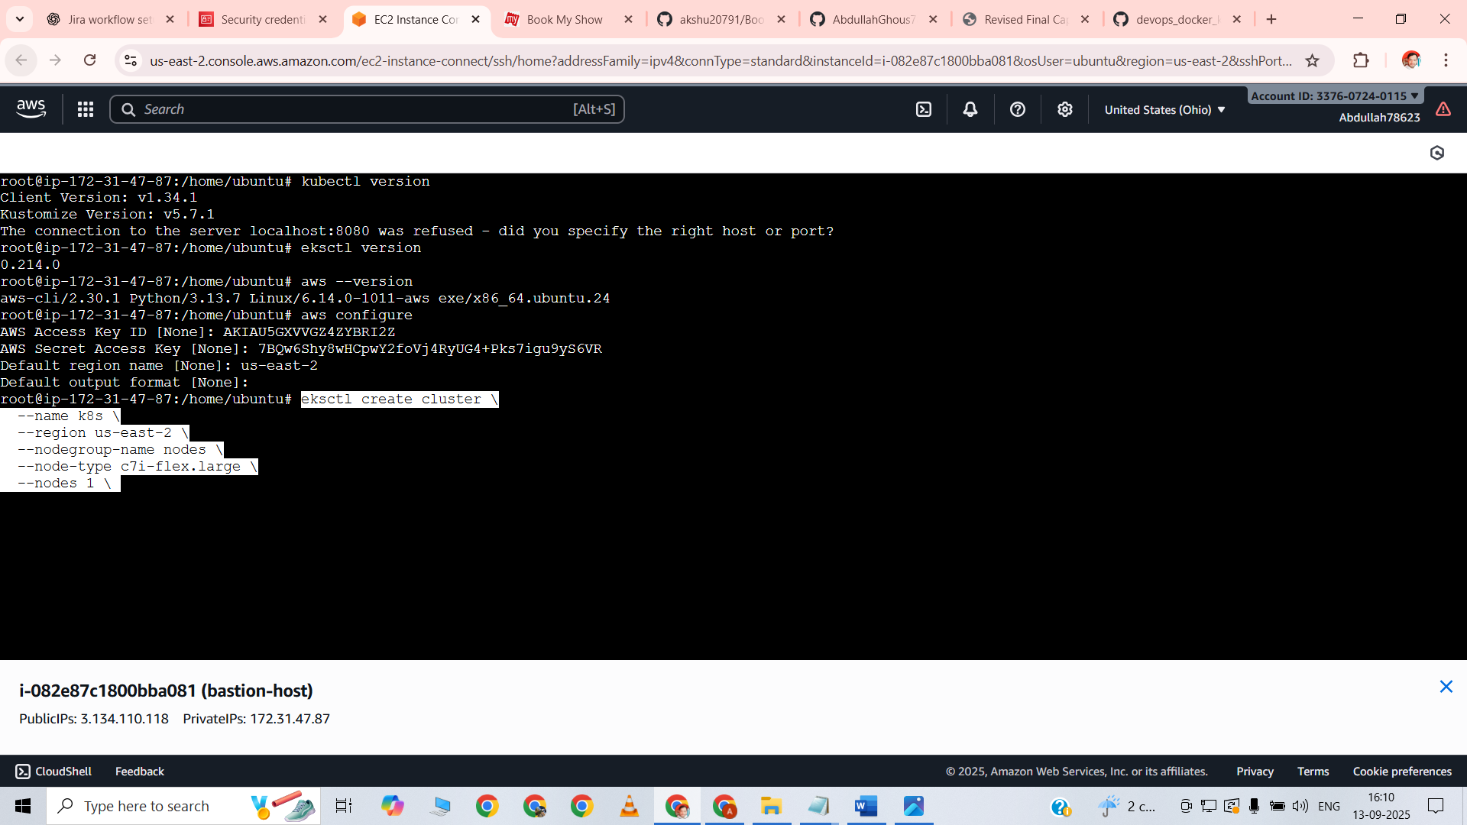

Started the Kubernetes setup by installing the necessary tools on the EC2 instance, including eksctl, kubectl, and AWS CLI. Configured the AWS CLI with proper credentials to enable communication with the AWS environment. Using eksctl, executed the command to create an EKS cluster, which provisioned the necessary nodes and control plane on AWS. Verified the cluster creation using kubectl get nodes and kubectl get svc commands, confirming that all nodes were in a ready state and the cluster was operational. This step ensured that the Kubernetes environment was correctly set up and ready for deploying the Book-My-Show application.

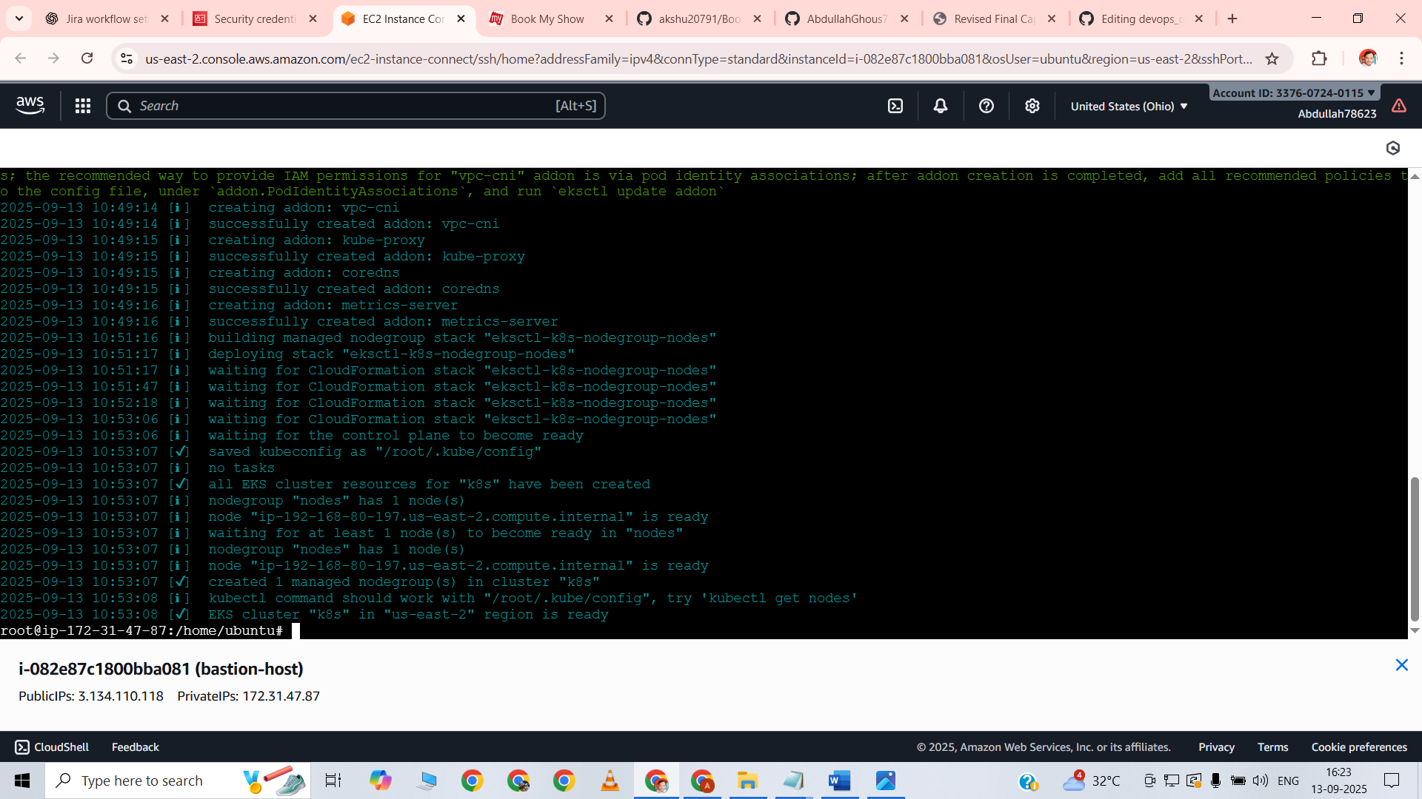

The EKS cluster was created successfully using eksctl. All nodes were provisioned and appeared in a ready state when checked with kubectl get nodes. The control plane and worker nodes were fully operational, confirming that the Kubernetes environment was set up correctly. This provided a stable foundation for deploying the Book-My-Show application on the cluster.

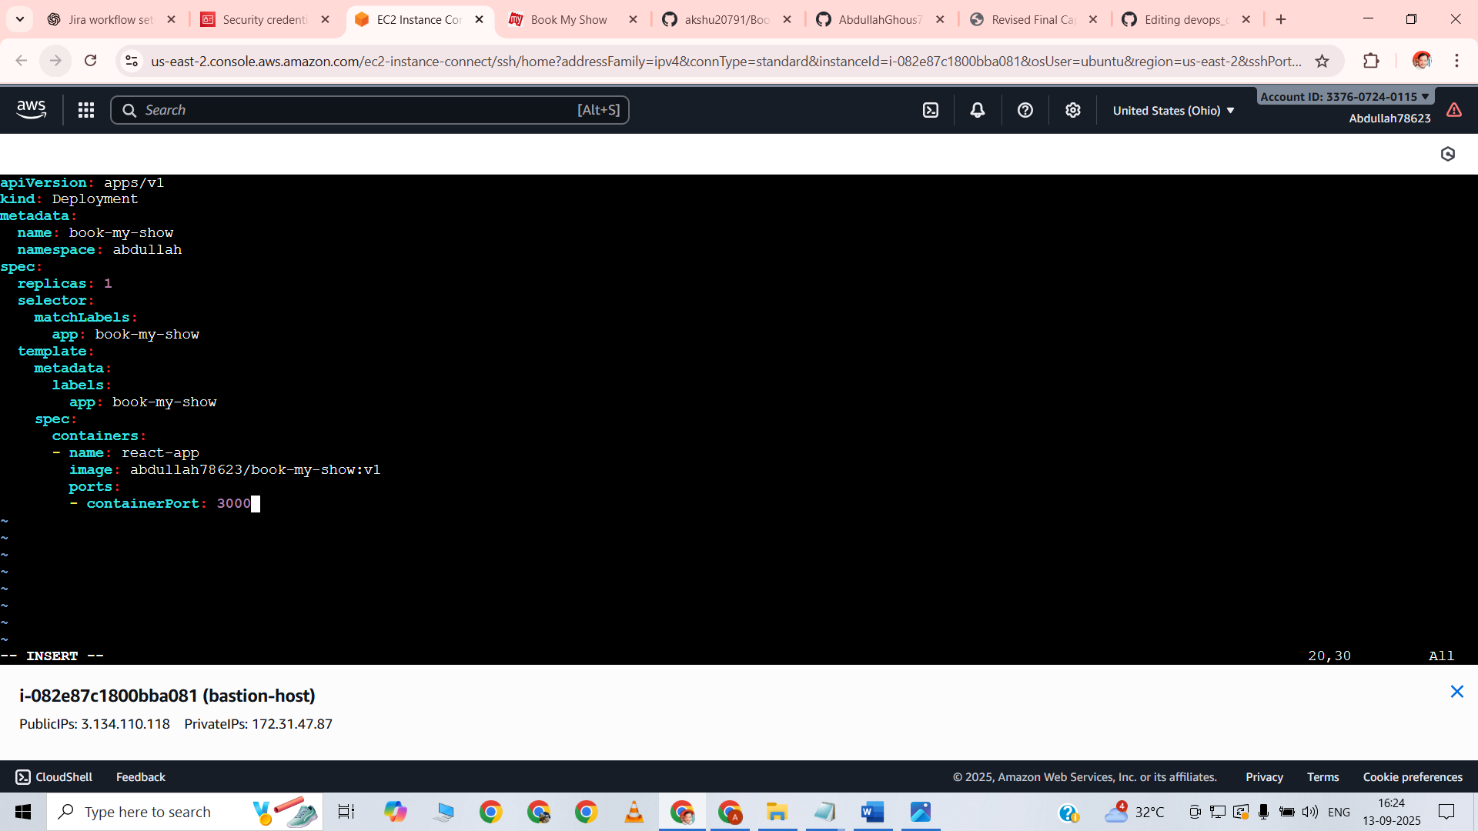

Created the deployment.yaml file for deploying the Book-My-Show application on the EKS cluster. Defined a Deployment with apiVersion: apps/v1 and set the name as book-my-show under the abdullah namespace. Configured the deployment to run 1 replica and used a selector to match the label app: book-my-show. In the Pod template, specified a container named react-app and referenced the DockerHub image abdullah78623/book-my-show:v1. Exposed container port 3000 to allow application access. This deployment manifest ensured that the application would be correctly deployed on Kubernetes using the Docker image pushed to DockerHub.

Deployment.yml file

apiVersion: apps/v1

kind: Deployment

metadata:

name: book-my-show

namespace: abdullah

spec:

replicas: 1

selector:

matchLabels:

app: book-my-show

template:

metadata:

labels:

app: book-my-show

spec:

containers:

- name: react-app

image: abdullah78623/book-my-show:v1

ports:

- containerPort: 3000

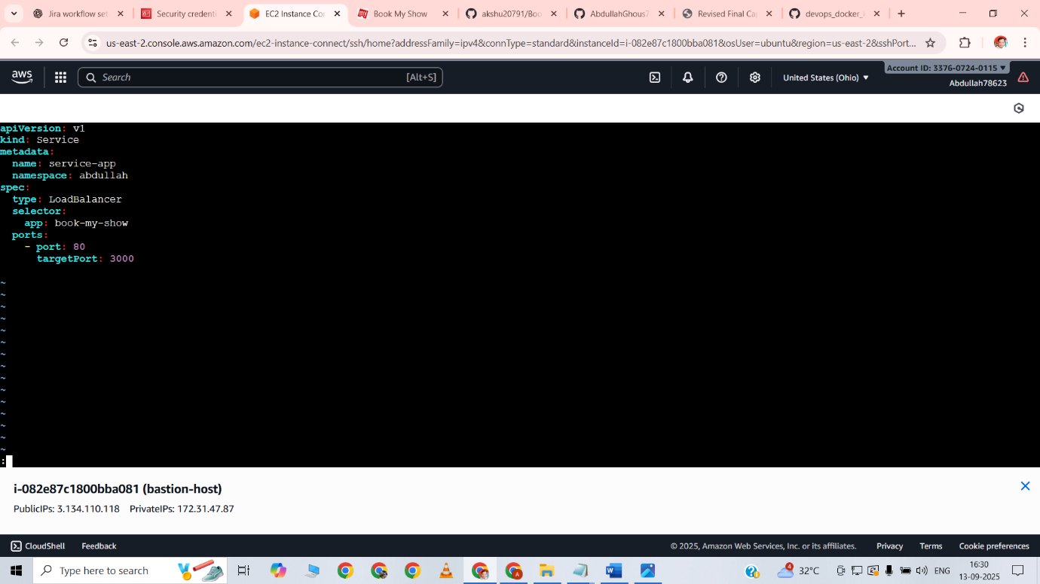

Created service.yaml file to expose the Book-My-Show application on Kubernetes  
Defined a Service with apiVersion: v1 and name service-app in the abdullah namespace  
Set the service type as LoadBalancer to allow external access to the application  
Configured the selector to match Pods with label app: book-my-show  
Mapped service port 80 to target port 3000 of the container  
This setup allowed the application to be accessed externally via the LoadBalancer URL provided by AWS

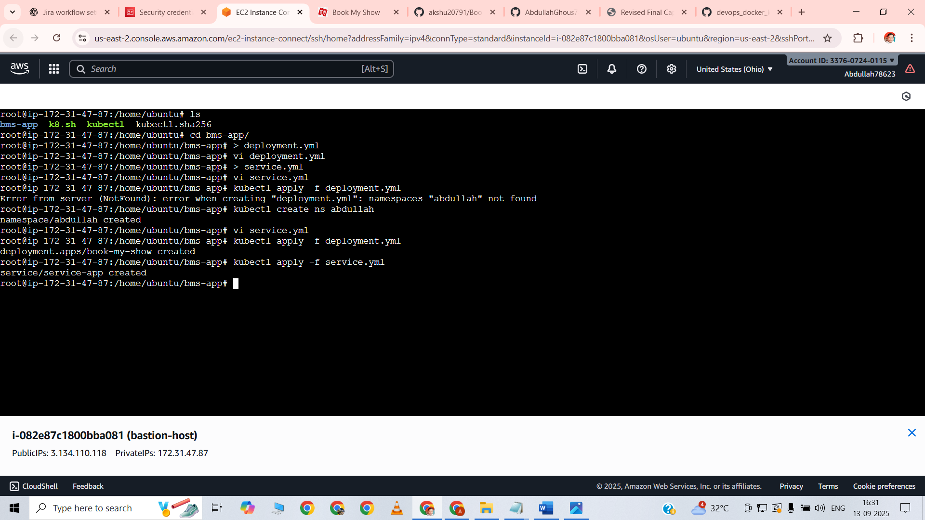

Created custom deployment.yaml and service.yaml files for the Book-My-Show application  
Applied both files on the EKS cluster using kubectl apply -f deployment.yaml and kubectl apply -f service.yaml  
Verified that the deployment and service were successfully created in the abdullah namespace  
Ensured that the Pods were running and the LoadBalancer service was exposing the application correctly

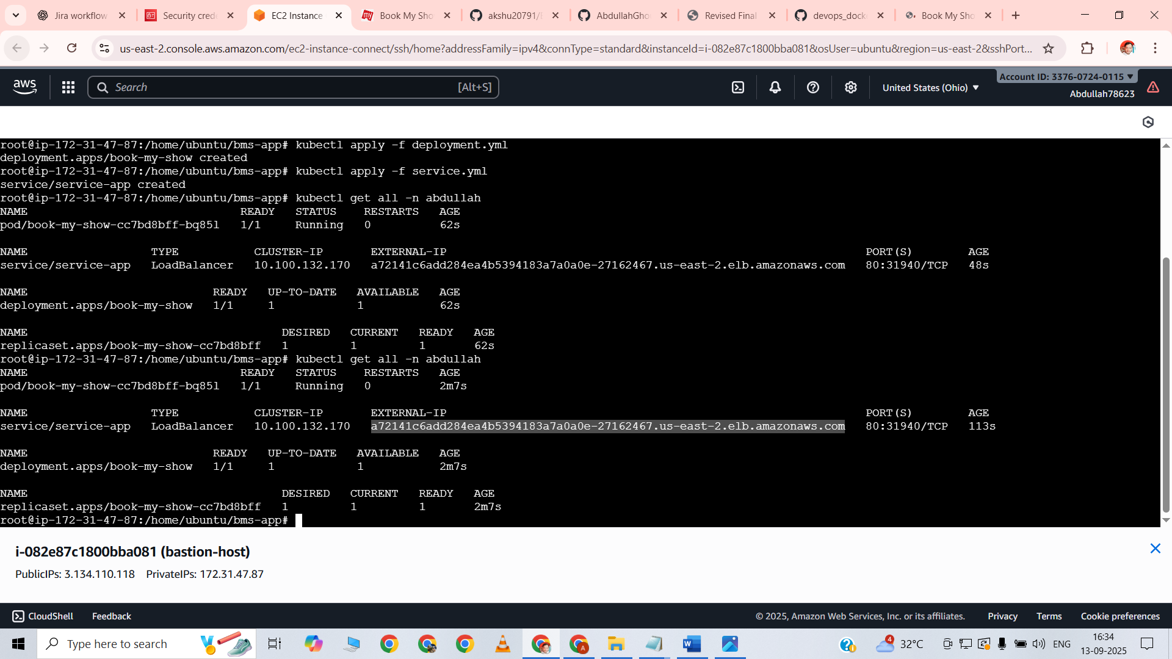

Executed kubectl get all -n abdullah to list all resources in the abdullah namespace  
Ran kubectl get pods -n abdullah to verify that all Pods were in a running state  
Used kubectl get svc -n abdullah to check that the Service was created and the LoadBalancer was assigned an external IP  
Confirmed that the Book-My-Show application was successfully deployed and accessible through Kubernetes

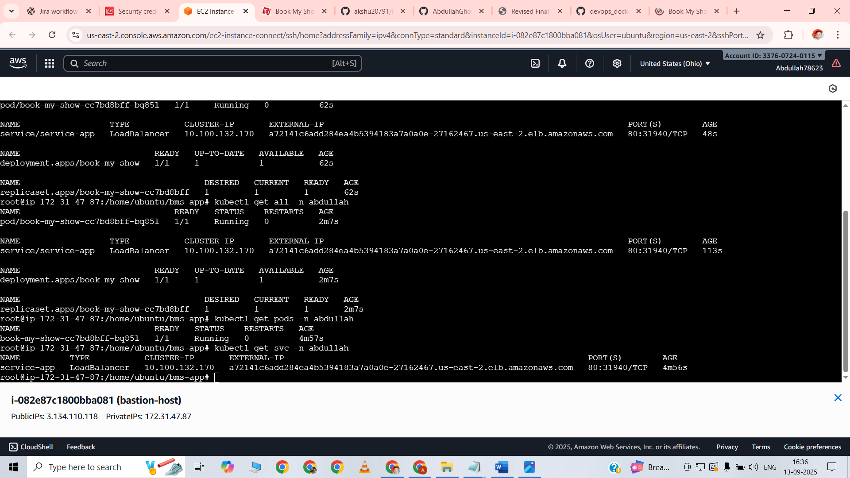

Executed kubectl get all -n abdullah to list all resources in the abdullah namespace  
Ran kubectl get pods -n abdullah to verify that all Pods were in a running state  
Used kubectl get svc -n abdullah to check that the Service was created and the LoadBalancer was assigned an external IP  
Confirmed that the Book-My-Show application was successfully deployed and accessible through Kubernetes



Accessed the Book-My-Show application using the LoadBalancer URL provided by the Kubernetes Service  
Verified that the application loaded successfully in the browser  
Confirmed that all features and pages of the application were functional  
Deployment on the EKS cluster was fully operational and accessible externally

TASK---6----MONITORING

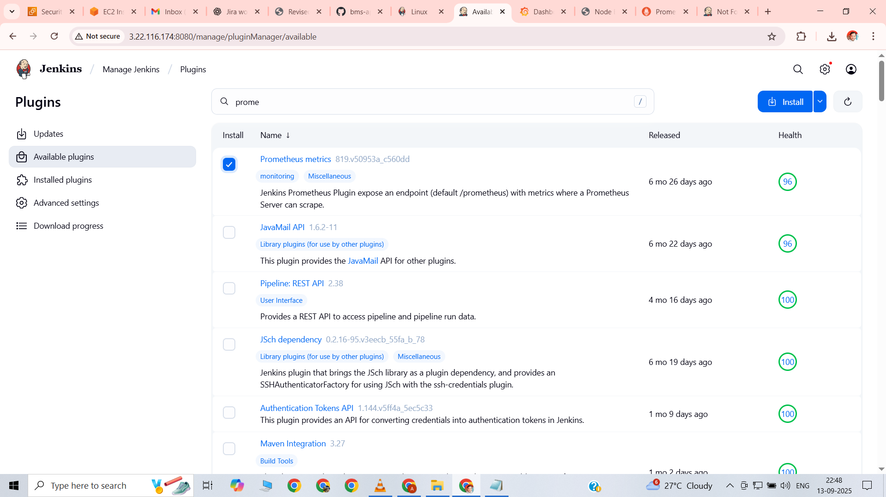

Installed Prometheus metrics plugin in Jenkins  
Enabled Jenkins to expose metrics for Prometheus scraping  
Configured Jenkins to start exporting CI/CD pipeline and build metrics  
Prepared Jenkins for integration with Prometheus and Grafana dashboards

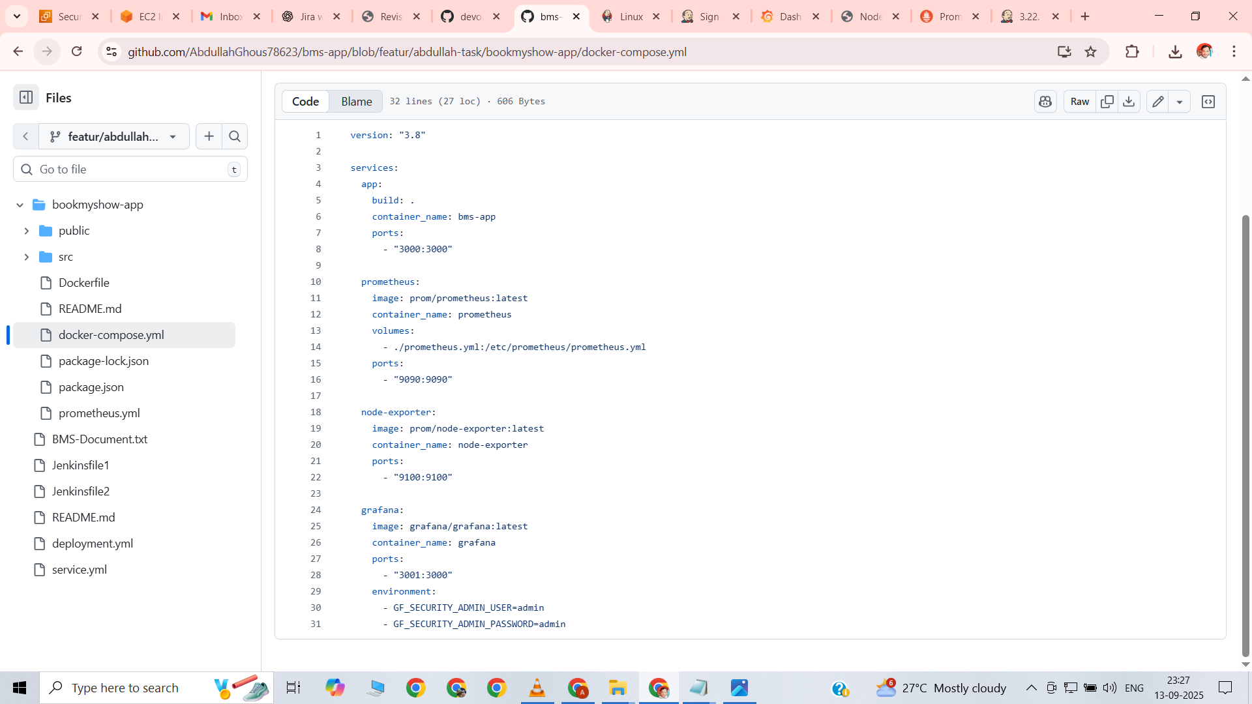

Created a single docker-compose.yml file to run the Book-My-Show application along with monitoring tools  
Defined four services:

App service: Builds the Book-My-Show React app from local Dockerfile, container named bms-app, exposed on port 3000  
Prometheus service: Uses prom/prometheus:latest image, container named prometheus, mounts prometheus.yml configuration, exposed on port 9090  
Node Exporter service: Uses prom/node-exporter:latest image, container named node-exporter, exposed on port 9100  
Grafana service: Uses grafana/grafana:latest image, container named grafana, exposed on port 3001, admin credentials set via environment variables  
This setup allowed running the application and monitoring stack together in a single environment for observability and metrics collection

Docker-compose.yml file

version: "3.8"

services:

app:

build: .

container_name: bms-app

ports:

- "3000:3000"

prometheus:

image: prom/prometheus:latest

container_name: prometheus

volumes:

- ./prometheus.yml:/etc/prometheus/prometheus.yml

ports:

- "9090:9090"

node-exporter:

image: prom/node-exporter:latest

container_name: node-exporter

ports:

- "9100:9100"

grafana:

image: grafana/grafana:latest

container_name: grafana

ports:

- "3001:3000"

environment:

- GF_SECURITY_ADMIN_USER=admin

- GF_SECURITY_ADMIN_PASSWORD=admin

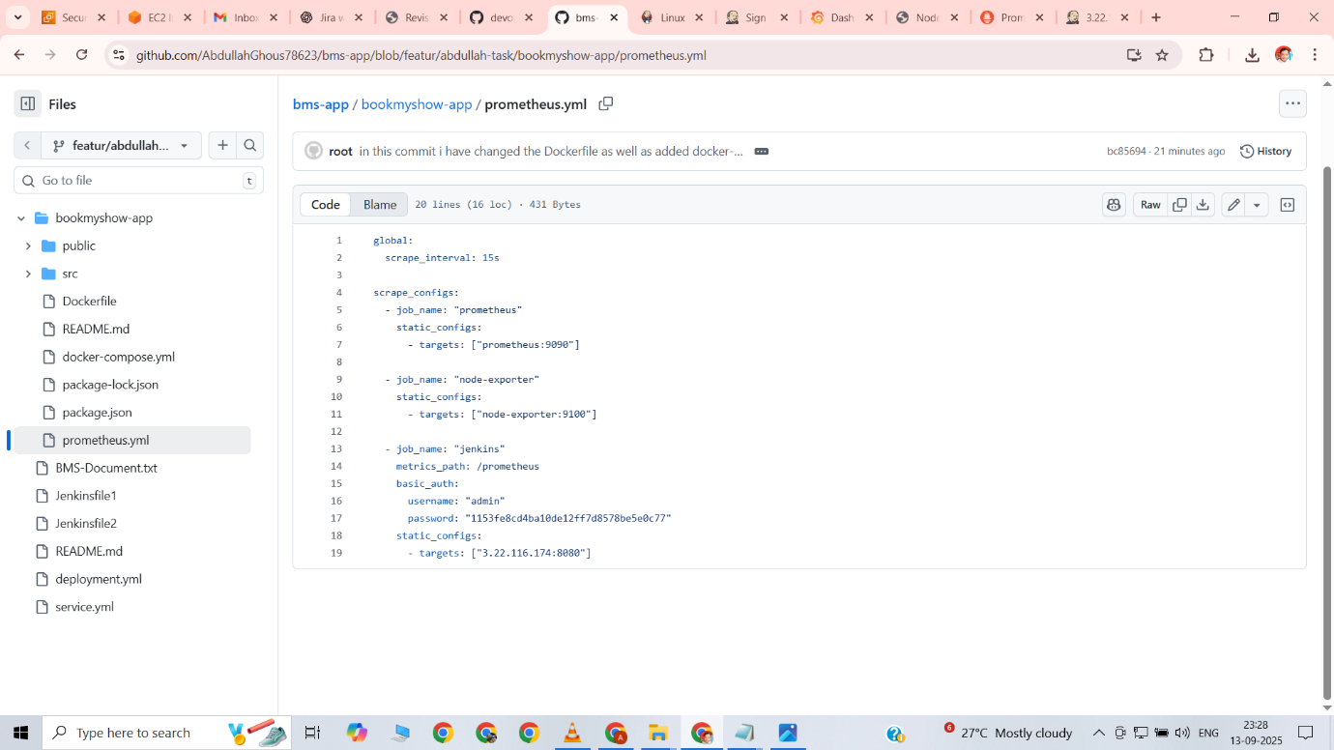

Created prometheus.yml configuration file for Prometheus metrics scraping

Set global scrape_interval to 15 seconds for periodic metric collection  
Added three scrape jobs:

Prometheus job: Scrapes metrics from the Prometheus container itself on port 9090  
Node Exporter job: Scrapes system-level metrics from Node Exporter container on port 9100  
Jenkins job: Scrapes Jenkins metrics from http://3.22.116.174:8080/prometheus, configured basic authentication with username admin and API token  
This configuration allowed Prometheus to collect metrics from the application environment, system nodes, and Jenkins for visualization in Grafana dashboards

Prometheus.yml file

global:

scrape_interval: 15s

scrape_configs:

- job_name: "prometheus"

static_configs:

- targets: ["prometheus:9090"]

- job_name: "node-exporter"

static_configs:

- targets: ["node-exporter:9100"]

- job_name: "jenkins"

metrics_path: /prometheus

basic_auth:

username: "admin"

password: "1153fe8cd4ba10de12ff7d8578be5e0c77"

static_configs:

- targets: ["3.22.116.174:8080"]

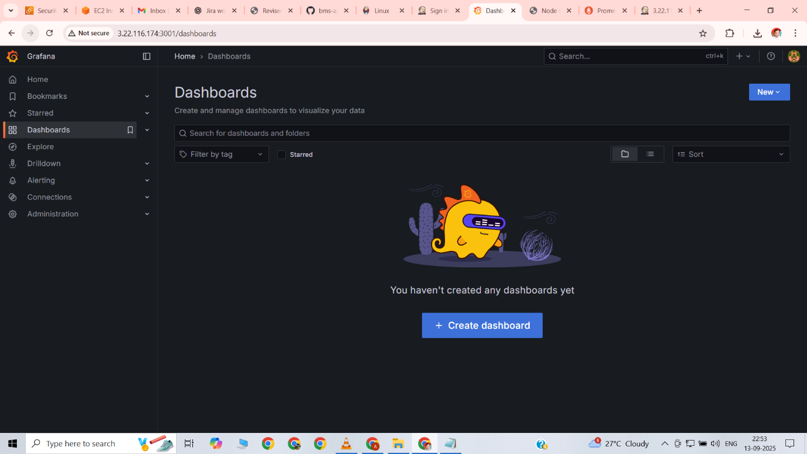

Grafana accessed

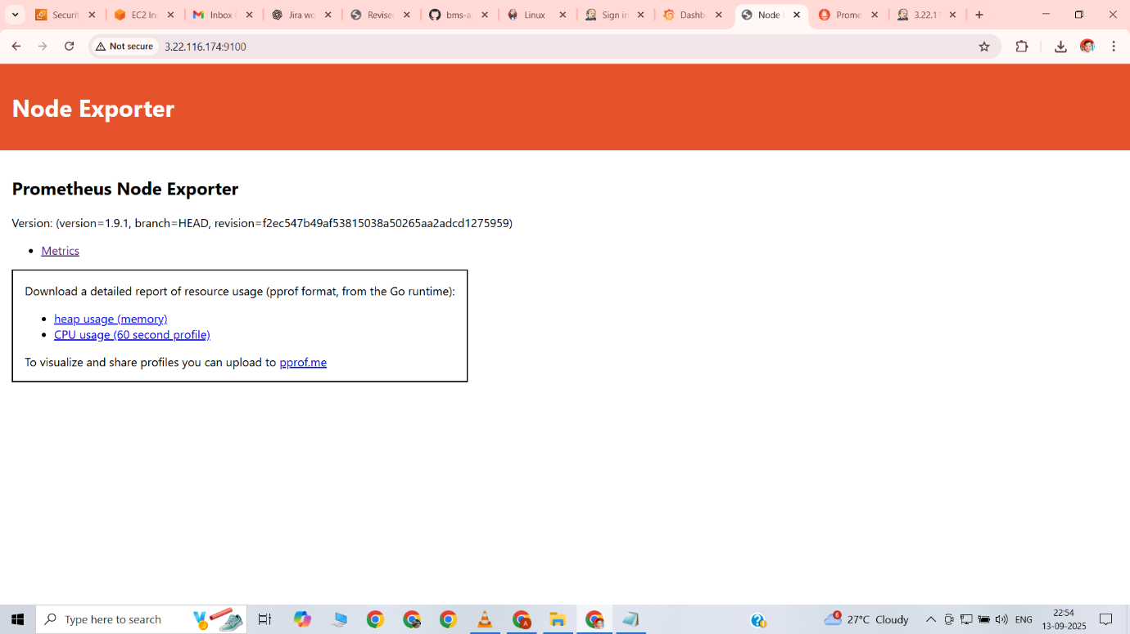

Node exporter accessed

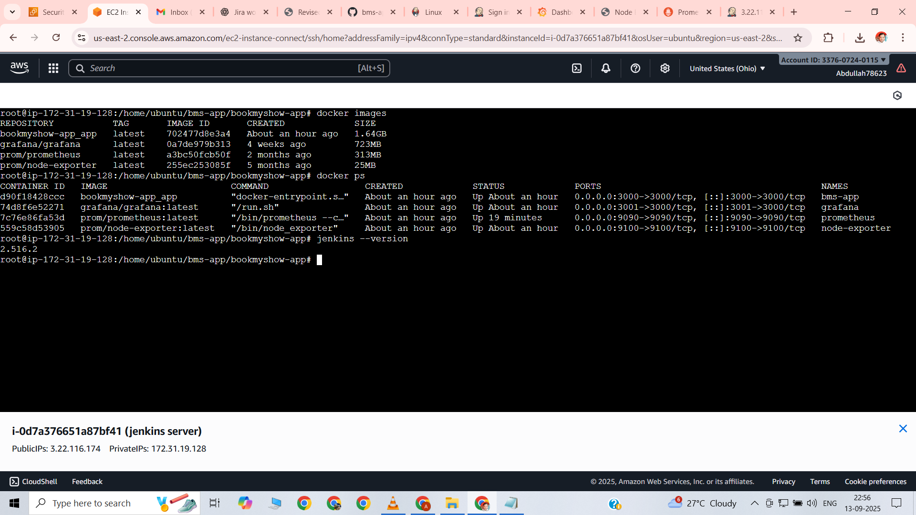

All up and running

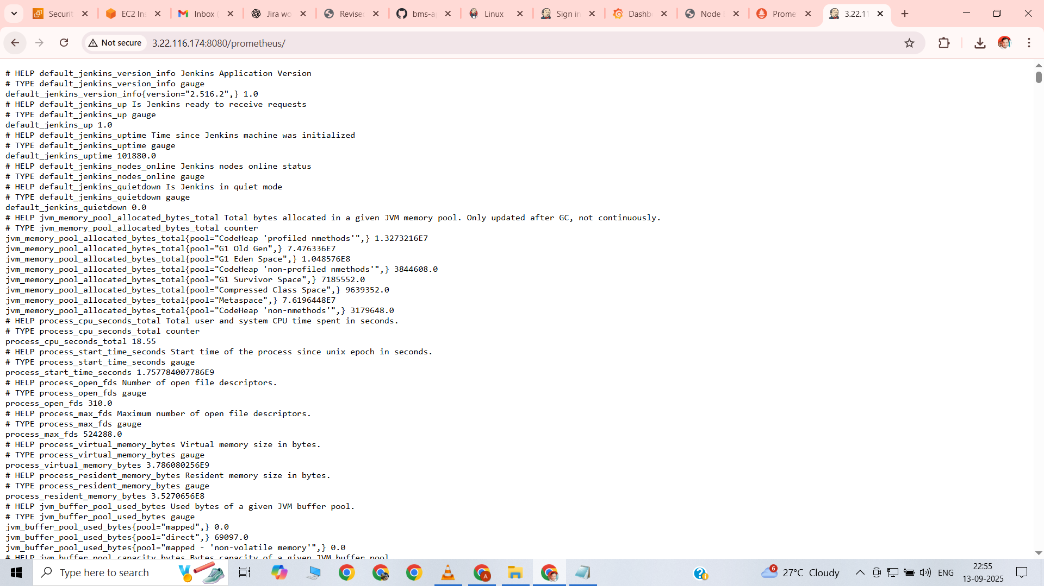

Accessed Prometheus UI on http://<EC2-IP>:8080/prometheus  
Verified that Prometheus was running and able to scrape metrics from all configured targets  
Checked that Prometheus successfully collected metrics from the application, Node Exporter, and Jenkins  
This confirmed that the monitoring stack was operational and ready for Grafana integration

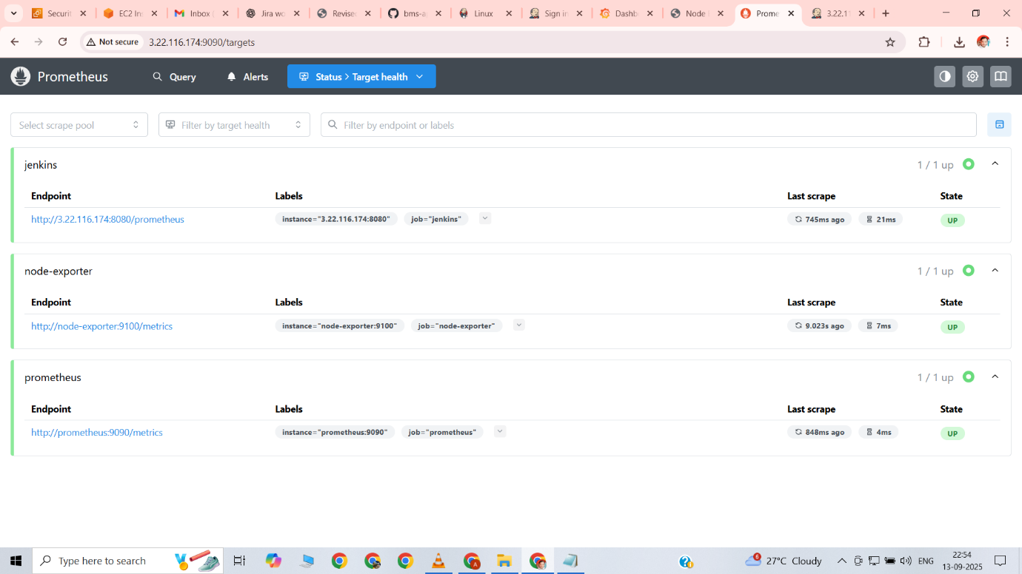

Opened the Prometheus Targets page to verify all configured endpoints  
Confirmed that all targets – Prometheus itself, Node Exporter, and Jenkins – were in an UP state  
Scraping intervals were running as expected, and metrics were being collected successfully  
This validated that Prometheus was properly monitoring the application environment and Jenkins pipelines

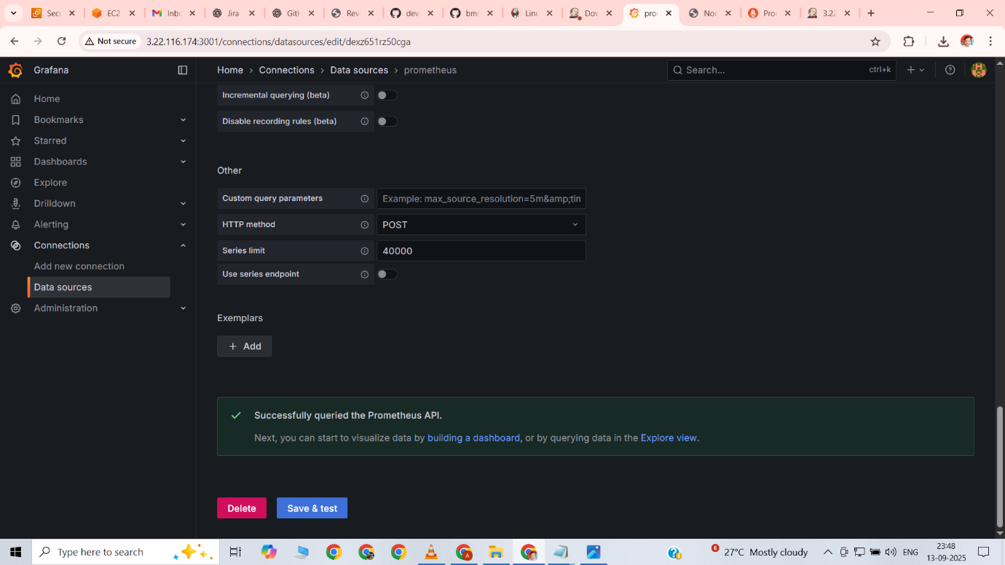

Logged into Grafana UI on http://<EC2-IP>:3001  
Added Prometheus as a data source using URL http://prometheus:9090  
Configured Grafana to authenticate and connect to Prometheus for metrics visualization  
Confirmed that Grafana successfully connected to Prometheus and was able to query metrics

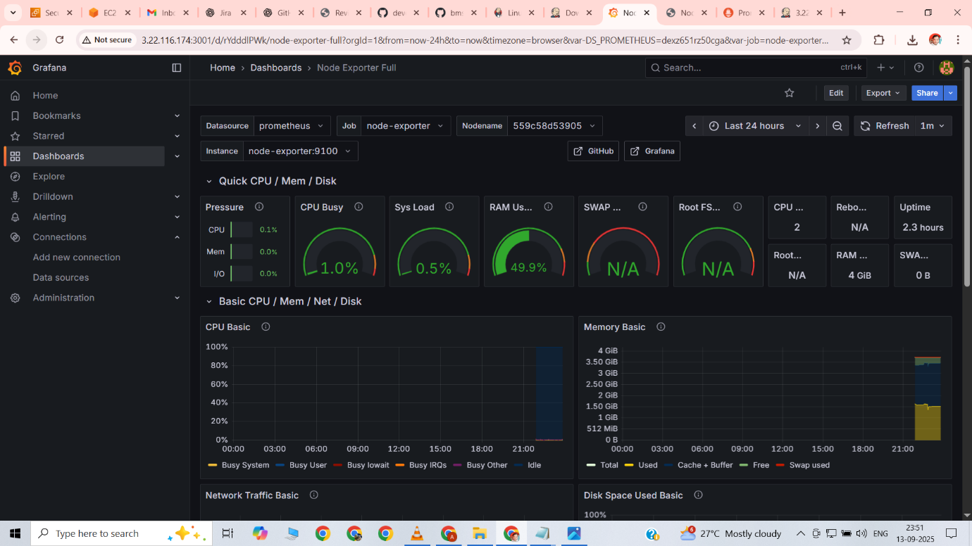

Imported Node Exporter dashboard in Grafana using dashboard ID 1860  
Verified that system metrics such as CPU usage, RAM utilization, disk space, and network statistics were displayed correctly  
Confirmed that the Node Exporter container metrics were being collected and visualized in real-time  
This validated that Grafana was successfully displaying system health of the EC2 instance running the application and monitoring stack

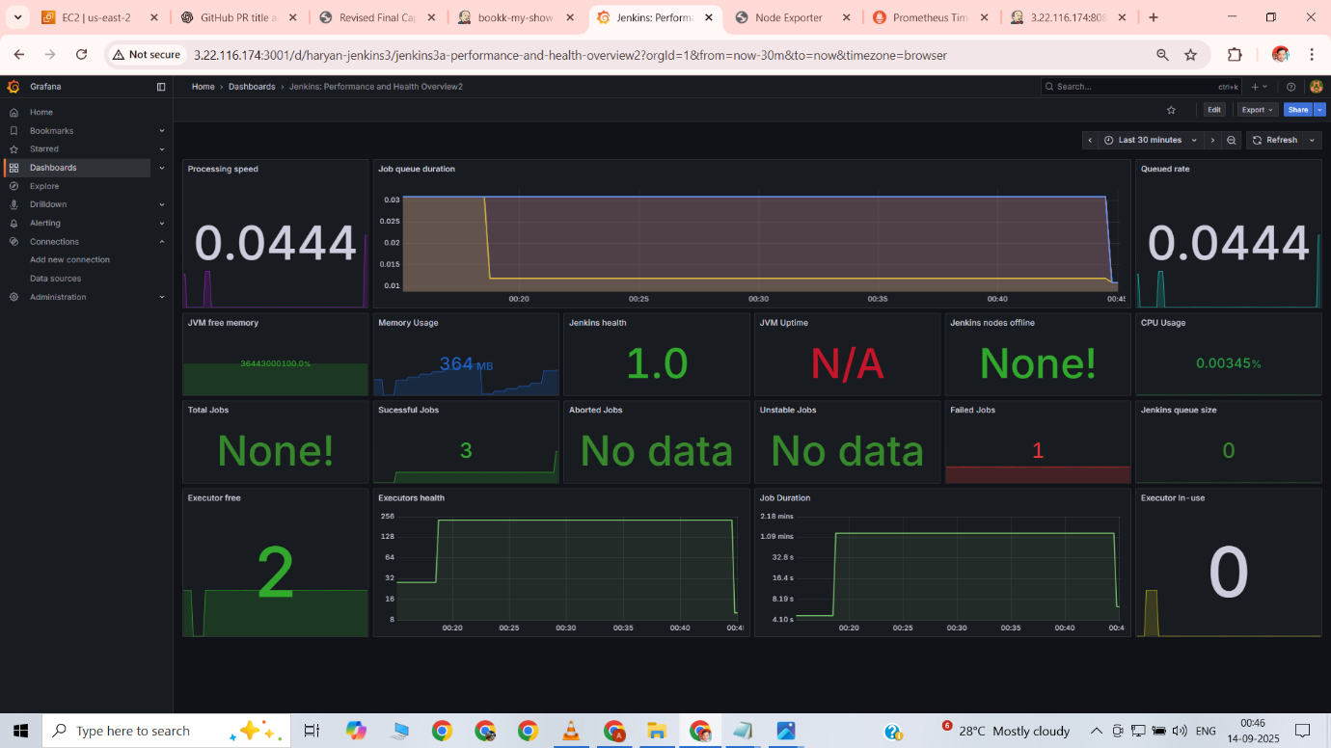

Imported Jenkins Performance dashboard in Grafana using dashboard ID 9964  
Verified that Jenkins CI/CD metrics such as build status, pipeline duration, and success/failure trends were displayed  
Confirmed that Prometheus was successfully scraping Jenkins metrics and Grafana was visualizing them in real-time  
This validated end-to-end monitoring of Jenkins pipelines along with the application and system metrics

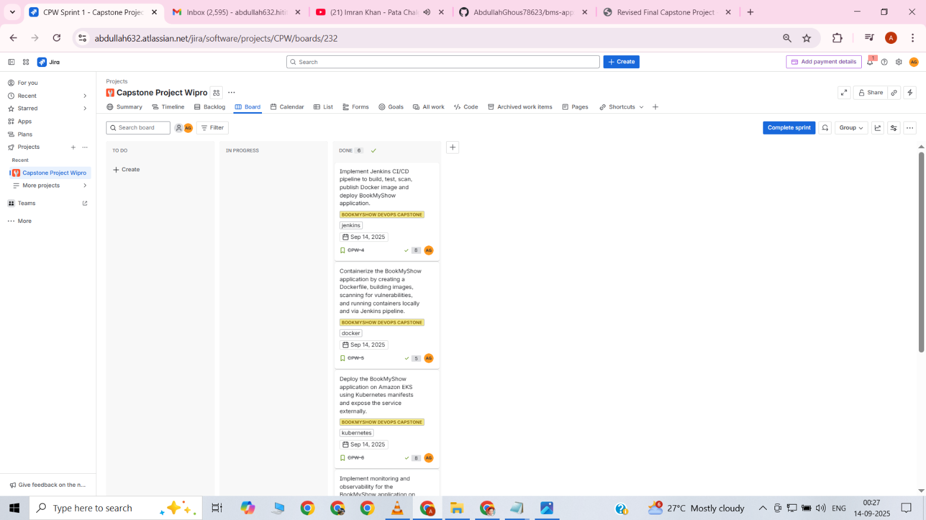

Moved all tasks and stories in Jira from In Progress to Done  
Verified that each story under the Epic “BookMyShow DevOps Capstone” was completed  
Ensured that task statuses reflected accurate progress for Jira, GitHub, Jenkins, Docker, Kubernetes, and Monitoring  
This confirmed that the entire DevOps lifecycle for the project was completed and tracked successfully

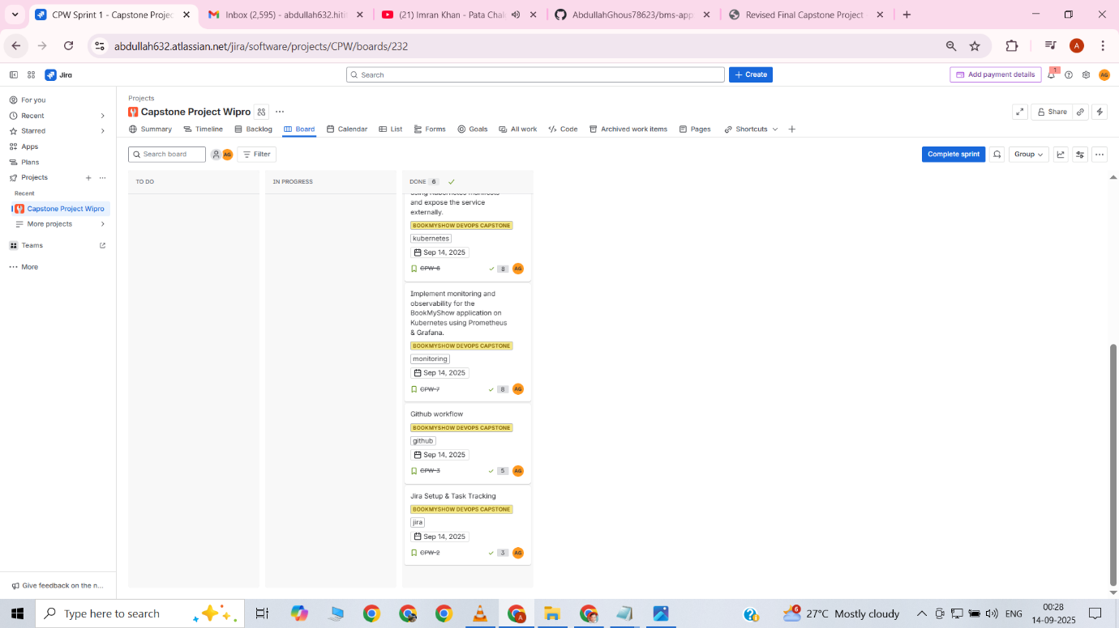

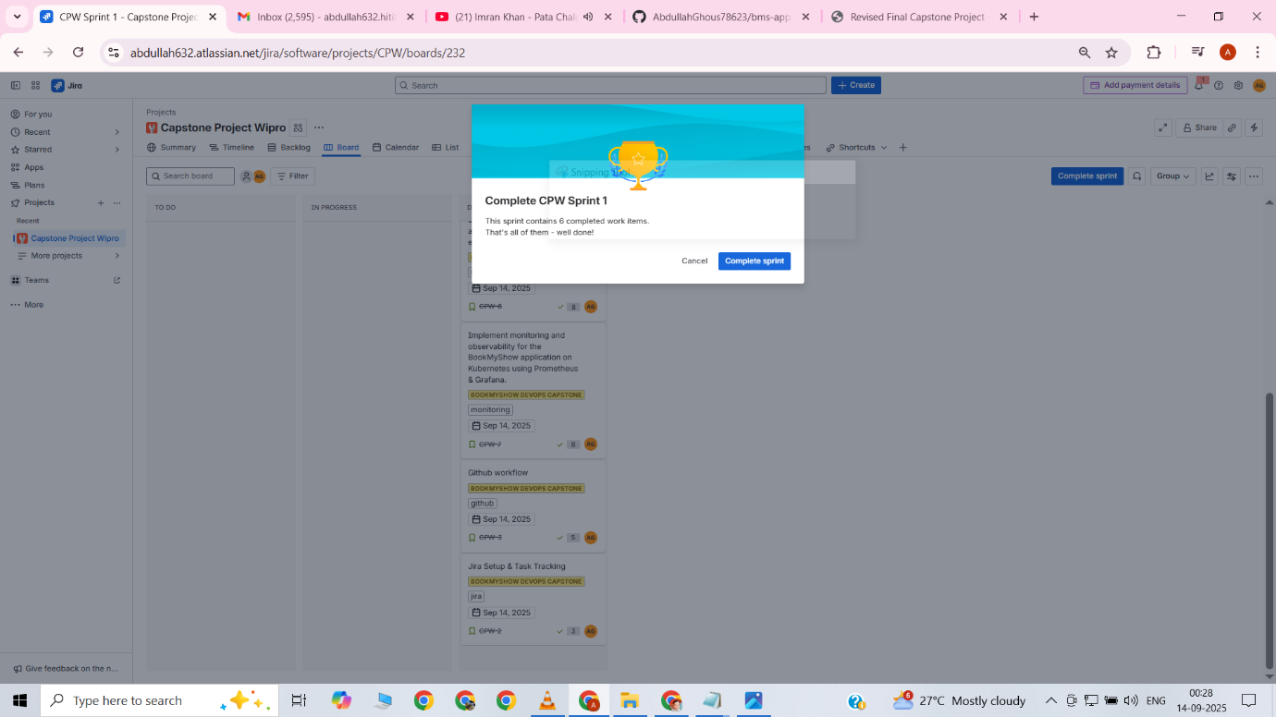

Received a congratulatory pop-up in Jira indicating successful completion of the sprint  
Confirmed that all planned stories and tasks were completed within the sprint duration  
Validated that the sprint goal for “BookMyShow DevOps Capstone” was achieved successfully

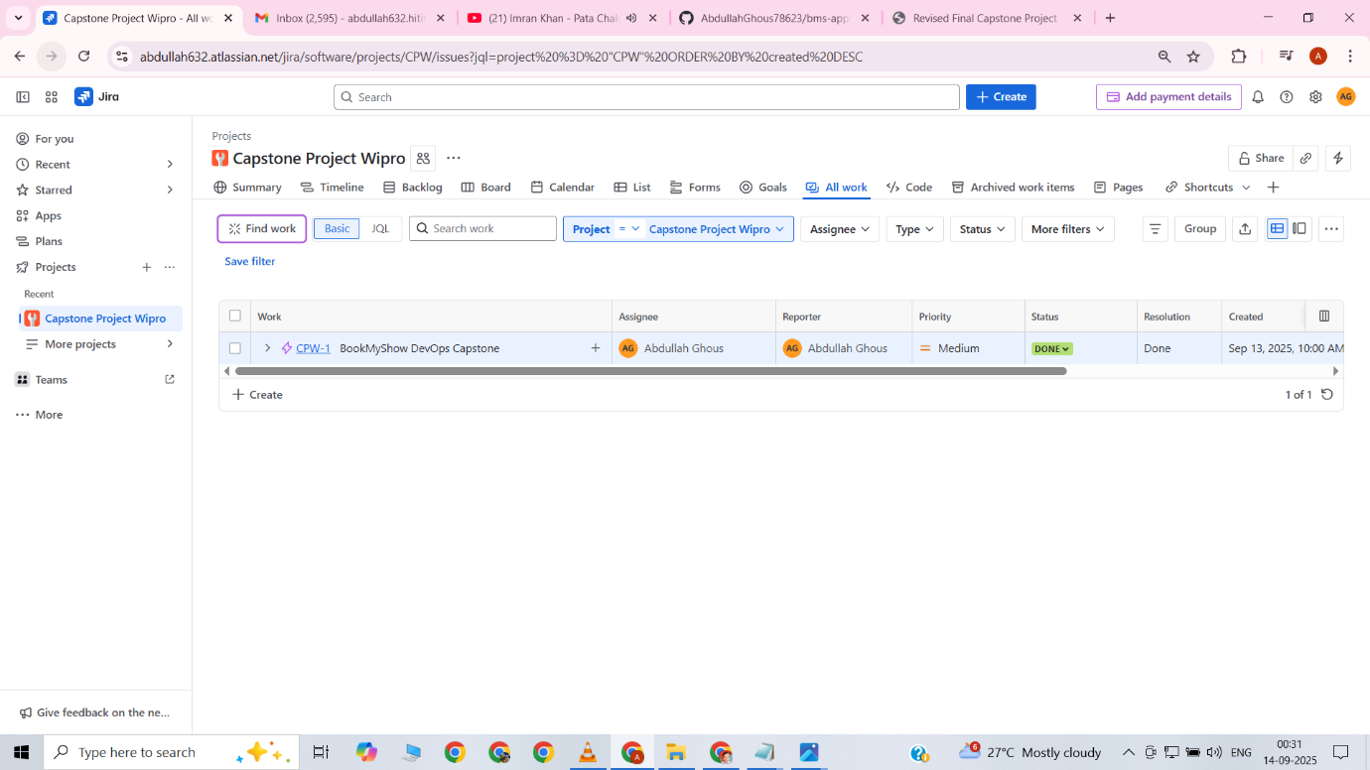

Conclusion

This project successfully demonstrated the **end-to-end implementation of a modern DevOps pipeline** using a real-world application scenario. By integrating tools such as **Jira, GitHub, Jenkins, SonarQube, Docker, Kubernetes, Terraform, Prometheus, and Grafana**, the application lifecycle was fully automated — from **planning and coding** to **deployment and monitoring**.

All the defined deliverables were completed, and the application was deployed on a scalable and reliable **EKS cluster** with proper monitoring and security checks in place. This not only highlights the power of **DevOps practices** in streamlining software delivery but also proves the importance of **automation, collaboration, and continuous improvement** in modern software engineering.

The journey through this project reinforced the value of adopting DevOps in real-world enterprises:

* Faster and more reliable deployments.
* Improved code quality and security.
* Enhanced visibility and monitoring.
* Scalable infrastructure that adapts to business needs.

With all tasks successfully moved to **Done**, this project stands as a complete demonstration of **DevOps best practices applied to a real-world application**.

Name-ABDULLAH GHOUS

PROJECT-NAME-CAPSTONE_PROJECT.